UNITED STATES
SECURITIES AND EXCHANGE COMMISSION
Washington, D.C. 20549

FORM 8-K

CURRENT REPORT
Pursuant to Section 13 or 15(d) of The Securities Exchange Act of 1934

Date of Report (Date of earliest event reported): July 22, 2026

BankUnited, Inc.
(Exact name of registrant as specified in its charter)
Delaware |  |  |  |  |  | 001-35039 |  |  |  |  |  | 27-0162450
(State of Incorporation) |  |  |  |  |  | (Commission File Number) |  |  |  |  |  | (I.R.S. Employer Identification No.)
14817 Oak Lane, |  |  | Miami Lakes, |  |  | FL |  |  |  |  |  | 33016
(Address of principal executive offices) |  |  |  |  |  |  |  |  |  |  |  | (Zip Code)

(Registrant’s telephone number, including area code): (305) 569-2000

Check the appropriate box below if the Form 8-K filing is intended to simultaneously satisfy the filing obligation of the registrant under any of the following provisions:

☐ Written communications pursuant to Rule 425 under the Securities Act (17 CFR 230.425)
☐ Soliciting material pursuant to Rule 14a-12 under the Exchange Act (17 CFR 240.14a-12)
☐ Pre-commencement communications pursuant to Rule 14d-2(b) under the Exchange Act (17 CFR 240.14d-2(b))
☐ Pre-commencement communications pursuant to Rule 13e-4(c) under the Exchange Act (17 CFR 240.13e-4(c))
Securities registered pursuant to Section 12(b) of the Act:
Class |  |  |  |  |  | Trading Symbol |  |  |  |  |  | Name of Exchange on Which Registered
Common Stock, $0.01 Par Value |  |  |  |  |  | BKU |  |  |  |  |  | New York Stock Exchange
Indicate by check mark whether the registrant is an emerging growth company as defined in Rule 405 of the Securities Act of 1933 (§230.405) or Rule 12b-2 of the Securities Exchange Act of 1934 (§240.12b-2).
Emerging growth company ☐
If an emerging growth company, indicate by check mark if the registrant has elected not to use the extended transition period for complying with any new or revised financial accounting standards provided pursuant to Section 13(a) of the Exchange Act ☐

Item 2.02 Results of Operations and Financial Condition.

On July 22, 2026, BankUnited, Inc. (the “Company”) reported its results for the quarter ended June 30, 2026. A copy of the Company’s press release containing this information and slides containing supplemental information related to this release are being furnished as Exhibit 99.1 and Exhibit 99.2, respectively, to this Current Report on Form 8-K and are incorporated herein by reference.

Item 9.01 Financial Statements and Exhibits.

(d) Exhibits.
Exhibit  Number |  |  |  |  |  | Description
99.1 |  |  |  |  |  | Press release dated |  |  | July 22, 2026
99.2 |  |  |  |  |  | Supplemental information relating to the press release dated |  |  | July 22, 2026

2

SIGNATURE

Pursuant to the requirements of the Securities Exchange Act of 1934, the registrant has duly caused this report to be signed on its behalf by the undersigned hereunto duly authorized.

Dated: |  |  | July 22, 2026 |  |  | BANKUNITED, INC.
 |  |  |  |  |  | /s/ James G. Mackey
 |  |  |  |  |  | Name: |  |  | James G. Mackey
 |  |  |  |  |  | Title: |  |  | Chief Financial Officer

3

Exhibit 99.1
4

BankUnited, Inc. Reports 2Q 2026 Net Income of $71 million, $0.97 Diluted EPS
Strong Franchise Momentum Driven by Record Non-Interest-Bearing Deposits, Improved Credit Quality and Solid Fee Income Performance

Miami Lakes, Fla. — July 22, 2026 — BankUnited, Inc. (the “Company”) (NYSE: BKU) today announced financial results for the quarter ended June 30, 2026.

Chairman, President and Chief Executive Officer Rajinder Singh commented, "Our second quarter performance reflects continued progress in strengthening the franchise and enhancing the quality of our balance sheet. Record non-interest-bearing deposits, solid fee income performance, and improved credit quality highlight the meaningful progress we have made over the past year. We remain focused on disciplined execution, deepening customer relationships, and building a stronger, more resilient franchise that supports long-term shareholder value creation."

Second Quarter Financial Highlights
 |  |  | Quarter Ended |  |  |  |  |  |  |  |  |  |  |  |  |  |  |  |  |  | Change From
($ in millions except per share data) |  |  | 2Q26 |  |  |  |  |  | 1Q26 |  |  |  |  |  | 2Q25 |  |  |  |  |  | 1Q26 |  |  |  |  |  | 2Q25
Net income |  |  | $ | 70.7 |  |  |  |  | $ | 61.9 |  |  |  |  | $ | 68.8 |  |  |  |  | $ | 8.8 |  |  |  |  | $ | 1.9
Diluted EPS |  |  | $ | 0.97 |  |  |  |  | $ | 0.83 |  |  |  |  | $ | 0.91 |  |  |  |  | $ | 0.14 |  |  |  |  | $ | 0.06
PPNR1 |  |  | $ | 109.9 |  |  |  |  | $ | 106.3 |  |  |  |  | $ | 109.6 |  |  |  |  | $ | 3.6 |  |  |  |  | $ | 0.3
ROA2 |  |  | 0.81 |  | % |  |  |  | 0.72 |  | % |  |  |  | 0.78 |  | % |  |  |  | 0.09 |  | % |  |  |  | 0.03 |  | %
ROE2 |  |  | 9.3 |  | % |  |  |  | 8.1 |  | % |  |  |  | 9.4 |  | % |  |  |  | 1.2 |  | % |  |  |  | (0.1) |  | %
Net interest margin2 |  |  | 3.06 |  | % |  |  |  | 2.99 |  | % |  |  |  | 2.93 |  | % |  |  |  | 0.07 |  | % |  |  |  | 0.13 |  | %
Deposits |  |  | •Average Total Deposits (excluding brokered): Up $811 million from prior quarter and up $1.5 billion from a year ago.
 |  |  | • Non-Interest Demand Deposits (NIDDA):
 |  |  | ◦Ending NIDDA up $991 million, or 11%, from prior quarter and $822 million, or 9%, from a year ago.
 |  |  | ◦Average NIDDA up $564 million, or 7%, from prior quarter and $1 billion, or 13% from a year ago.
 |  |  | ◦Represents 34.4% of total deposits, up from 31.8% a year ago. This represents the highest NIDDA balance and highest percentage of total deposits in the Company's history.
 |  |  | •Wholesale funding declined by $1.4 billion for both the prior quarter and from a year ago, reflecting continued balance-sheet repositioning. Brokered deposits represents 10.5% of total deposits.
Loans |  |  | •Average Core Loans increased $195 million, or 1%, from prior quarter and increased $643 million, or 4%, from a year ago.
 |  |  | •Total Average Loans were essentially flat vs both prior quarter and prior year, due to continued purposeful runoff in non-core loans.
Credit |  |  | •NPLs down $51 million, or 19%, from the prior quarter and $152 million, or 40%, from a year ago.
 |  |  | •ACL to NPLs coverage ratio increased to 97.14% from 75.90% in the prior quarter.
 |  |  | •Criticized and classified loans modestly increased $7 million, or 1%, and were down $170 million, or 14%, from a year ago.
Share Repurchases |  |  | •Approximately 1.1 million shares repurchased in Q2 for an aggregate of $50.1 million.
(1) Represents a non-GAAP measure. See "Non-GAAP Financial Measures" section for a reconciliation of non-GAAP financial measures to GAAP financial measures.
(2) Annualized for the three months ended June 30, 2026, March 31, 2026, and June 30, 2025.

1

Notable items that impacted results:
The following table presents notable items, on a pre-tax basis, that impacted results for the periods presented (in thousands):
 |  |  | Quarter Ended
 |  |  | 2Q26 |  |  |  |  |  | 1Q26 |  |  |  |  |  | 2Q25
Compensation-related items |  |  | $ | — |  |  |  |  | $ | (5,358) |  |  |  |  | $ | —
Release of FDIC Special Assessment accrual |  |  | — |  |  |  |  |  | 6,669 |  |  |  |  |  | —
 |  |  | $ | — |  |  |  |  | $ | 1,311 |  |  |  |  | $ | —

Net Interest Income & Margin
Net Interest Income |  |  |  |  |  |  |  |  |  |  |  | Net Interest Margin (NIM)
p$6.3 million or 3% from prior quarter |  |  |  |  |  | p $9.2 million or 4% from 2Q 2025 |  |  |  |  |  | p 7 bps from prior quarter |  |  |  |  |  | p 13 bps from 2Q 2025
Net interest income and margin increased from the prior quarter due to the following factors:
•Impact of the growth in NIDDA balances and reduced use of brokered deposits. Deposit pricing continued to improve, contributing to lower funding costs; average cost of deposits declined to 2.05% from 2.12% from the prior quarter.
•The tax equivalent yield on investment securities increased reflecting the benefit of securities purchased during the first quarter as periods of market volatility and spread widening created attractive investment opportunities.
Net interest income and margin also increased from the same quarter of the prior year due to the following factors:
•Average NIDDA grew by $1 billion while average interest bearing liabilities declined by $1.1 billion.
•Partially offset by the decrease of tax equivalent yields on investment securities and loans as variable rate assets repriced faster than continued improvement in funding cost and funding mix dynamics due to lower SOFR/Fed funds basis.

Non-Interest Income and Non-Interest Expense
The following table summarizes non-interest income and non-interest expense for the periods presented (in millions):
 |  |  | Three Months Ended
 |  |  | 2Q26 |  |  |  |  |  | 1Q26 |  |  |  |  |  | 2Q25
Non-interest income |  |  | $ | 29.2 |  |  |  |  | $ | 24.7 |  |  |  |  | $ | 27.8
Non-interest expense |  |  | $ | 174.6 |  |  |  |  | $ | 167.4 |  |  |  |  | $ | 164.3
•Non-interest income increased from prior quarter, primarily reflecting higher capital markets revenue.
•Non-interest income increased compared to a year ago, primarily as a result of increase in deposit service charges and fees.
•Non-interest expense increased from prior quarter, after adjusting for the notable items summarized above, due to higher deposit-related costs, a loss associated with a single real estate owned asset disposition of $1.1 million, and elevated operational losses of $1.3 million.
•Non-interest expense increased compared to a year ago, primarily due to higher employee compensation and benefits.

2

Loans
•Average CRE loans increased by $147 million, or 2%, from prior quarter and increased by $630 million, or 10%, from a year ago.
•Average C&I loans were essentially flat from the prior quarter and from a year ago, largely due to strategic exits.
•Average MWL (Mortgage Warehouse Lending) loans up $82 million, or 13% from prior quarter and $115 million, or 19% from a year ago.
•Average Residential loan balances declined $174 million, or 3% from the prior quarter and $627 million, or 8% from a year ago; consistent with our balance sheet repositioning strategy.
Loan portfolio composition at the periods indicated are as follows (dollars in thousands):
 |  |  | 2Q26 |  |  |  |  |  |  |  |  |  | 1Q26 |  |  |  |  |  |  |  |  |  |  |  |  |  | 2Q25
 |  |  | Amortized Cost |  |  |  |  |  | Average Balance |  |  |  |  |  |  | Amortized Cost |  |  |  |  |  | Average Balance |  |  |  |  |  |  |  |  |  |  | Amortized Cost |  |  |  |  |  | Average Balance
Core loan segments:
CRE 1 |  |  | $ | 7,006,901 |  |  |  |  | $ | 6,938,213 |  |  |  |  |  | $ | 6,886,411 |  |  |  |  | $ | 6,790,769 |  |  |  |  |  |  |  |  |  | $ | 6,473,465 |  |  |  |  | $ | 6,308,051
C&I 2 |  |  | 8,681,166 |  |  |  |  |  | 8,706,525 |  |  |  |  |  |  | 8,885,932 |  |  |  |  |  | 8,752,335 |  |  |  |  |  |  |  |  |  |  | 8,685,815 |  |  |  |  |  | 8,744,513
MWL |  |  | 876,771 |  |  |  |  |  | 730,841 |  |  |  |  |  |  | 805,037 |  |  |  |  |  | 649,160 |  |  |  |  |  |  |  |  |  |  | 626,589 |  |  |  |  |  | 616,129
Municipal Finance |  |  | 636,945 |  |  |  |  |  | 630,329 |  |  |  |  |  |  | 616,486 |  |  |  |  |  | 618,192 |  |  |  |  |  |  |  |  |  |  | 694,639 |  |  |  |  |  | 694,657
Total core loans |  |  | 17,201,783 |  |  |  |  |  | 17,005,908 |  |  |  |  |  |  | 17,193,866 |  |  |  |  |  | 16,810,456 |  |  |  |  |  |  |  |  |  |  | 16,480,508 |  |  |  |  |  | 16,363,350
Other |  |  | 71,740 |  |  |  |  |  | 78,929 |  |  |  |  |  |  | 84,709 |  |  |  |  |  | 95,725 |  |  |  |  |  |  |  |  |  |  | 149,022 |  |  |  |  |  | 156,663
Residential |  |  | 6,655,550 |  |  |  |  |  | 6,754,430 |  |  |  |  |  |  | 6,856,354 |  |  |  |  |  | 6,928,828 |  |  |  |  |  |  |  |  |  |  | 7,303,997 |  |  |  |  |  | 7,380,985
Total loans |  |  | $ | 23,929,073 |  |  |  |  | $ | 23,839,267 |  |  |  |  |  | $ | 24,134,929 |  |  |  |  | $ | 23,835,009 |  |  |  |  |  |  |  |  |  | $ | 23,933,527 |  |  |  |  | $ | 23,900,998
Deposits
Deposit portfolio composition at the periods indicated are as follows (dollars in thousands):
 |  |  | 2Q26 |  |  |  |  |  |  |  |  |  | 1Q26 |  |  |  |  |  |  |  |  |  |  |  |  |  | 2Q25
 |  |  | Ending Balance |  |  |  |  |  | Average Balance |  |  |  |  |  |  | Ending Balance |  |  |  |  |  | Average Balance |  |  |  |  |  |  |  |  |  |  | Ending Balance |  |  |  |  |  | Average Balance
Non-Interest Bearing Demand |  |  | $ | 9,934,638 |  |  |  |  | $ | 9,027,557 |  |  |  |  |  | $ | 8,943,844 |  |  |  |  | $ | 8,463,491 |  |  |  |  |  |  |  |  |  | $ | 9,112,888 |  |  |  |  | $ | 7,993,915
Interest Bearing Demand |  |  | 6,619,044 |  |  |  |  |  | 6,365,179 |  |  |  |  |  |  | 6,449,405 |  |  |  |  |  | 6,033,099 |  |  |  |  |  |  |  |  |  |  | 5,583,663 |  |  |  |  |  | 5,407,538
Savings and Money Market |  |  | 9,958,785 |  |  |  |  |  | 10,083,767 |  |  |  |  |  |  | 9,939,985 |  |  |  |  |  | 10,245,692 |  |  |  |  |  |  |  |  |  |  | 10,171,156 |  |  |  |  |  | 10,355,700
Time |  |  | 2,368,781 |  |  |  |  |  | 3,251,965 |  |  |  |  |  |  | 4,026,866 |  |  |  |  |  | 3,751,256 |  |  |  |  |  |  |  |  |  |  | 3,778,234 |  |  |  |  |  | 3,919,526
Total deposits |  |  | $ | 28,881,248 |  |  |  |  | $ | 28,728,468 |  |  |  |  |  | $ | 29,360,100 |  |  |  |  | $ | 28,493,538 |  |  |  |  |  |  |  |  |  | $ | 28,645,941 |  |  |  |  | $ | 27,676,679
(1) Commercial real estate loans, including non-owner occupied commercial real estate and construction and land.
(2) Commercial and industrial loans, including owner-occupied commercial real estate.

3

Credit
Credit Quality
Credit quality metrics remained strong during Q2, as non-performing loans declined and criticized and classified loans modestly increased from the prior quarter.
•Non-Performing Loans: Down $51 million, or 19%, from prior quarter and down $152 million, or 40%, from a year ago.
•NPA Ratio: 0.66%, including 0.09% related to guaranteed portion of SBA loans, down from 0.79%, including 0.10% related to SBA, in prior quarter.
•Criticized and Classified Loans: Increased $7 million from prior quarter, reflecting continued portfolio monitoring, and down $170 million from a year ago.
•Net Charge-offs: Net Charge-offs for the quarter (annualized) was 0.11%, down 0.50% from prior quarter and 0.10% from a year ago.
The following table provides a breakdown of criticized and classified loans for the periods indicated (in thousands):
 |  |  | 2Q26 |  |  |  |  |  |  |  |  |  |  |  | 1Q26 |  |  |  |  |  |  |  |  |  |  |  | 2Q25
 |  |  | CRE |  |  |  |  |  | Total Commercial |  |  |  |  |  | CRE |  |  |  |  |  | Total Commercial |  |  |  |  |  | CRE |  |  |  |  |  | Total Commercial
Special mention |  |  | $ | 33,868 |  |  |  |  | $ | 175,198 |  |  |  |  | $ | 67,396 |  |  |  |  | $ | 177,859 |  |  |  |  | $ | 88,959 |  |  |  |  | $ | 130,879
Substandard - accruing |  |  | 411,167 |  |  |  |  |  | 686,274 |  |  |  |  |  | 418,033 |  |  |  |  |  | 622,436 |  |  |  |  |  | 520,955 |  |  |  |  |  | 745,811
Substandard - non-accruing |  |  | 36,255 |  |  |  |  |  | 156,208 |  |  |  |  |  | 74,584 |  |  |  |  |  | 211,293 |  |  |  |  |  | 152,634 |  |  |  |  |  | 317,958
Doubtful |  |  | — |  |  |  |  |  | 41,682 |  |  |  |  |  | 903 |  |  |  |  |  | 40,758 |  |  |  |  |  | — |  |  |  |  |  | 34,639
Total |  |  | $ | 481,290 |  |  |  |  | $ | 1,059,362 |  |  |  |  | $ | 560,916 |  |  |  |  | $ | 1,052,346 |  |  |  |  | $ | 762,548 |  |  |  |  | $ | 1,229,287
Allowance & Provision
Allowance levels and coverage remained appropriate during the periods presented, with changes reflecting lower net charge-offs, higher specific reserves, and improved asset quality. The following tables summarize the ACL, key coverage metrics, and changes across the periods presented (dollars in thousands):
 |  |  | ACL |  |  |  |  |  | ACL to Total Loans |  |  |  |  |  | Commercial ACL to Commercial Loans1 |  |  |  |  |  | ACL to Non-Performing Loans |  |  |  |  |  | Net Charge-offs to Average Loans2
2Q26 |  |  | $ | 217,516 |  |  |  |  | 0.91 |  | % |  |  |  | 1.30 |  | % |  |  |  | 97.14 |  | % |  |  |  | 0.11 |  | %
1Q26 |  |  | $ | 208,790 |  |  |  |  | 0.87 |  | % |  |  |  | 1.25 |  | % |  |  |  | 75.90 |  | % |  |  |  | 0.61 |  | %
2Q25 |  |  | $ | 222,730 |  |  |  |  | 0.93 |  | % |  |  |  | 1.36 |  | % |  |  |  | 59.18 |  | % |  |  |  | 0.21 |  | %
 |  |  | Three Months Ended
 |  |  | 2Q26 |  |  |  |  |  | 1Q26 |  |  |  |  |  | 2Q25
Beginning balance |  |  | $ | 208,790 |  |  |  |  | $ | 219,825 |  |  |  |  | $ | 219,747
Provision |  |  | 15,098 |  |  |  |  |  | 25,103 |  |  |  |  |  | 15,694
Net charge-offs |  |  | (6,372) |  |  |  |  |  | (36,138) |  |  |  |  |  | (12,711)
Ending balance |  |  | $ | 217,516 |  |  |  |  | $ | 208,790 |  |  |  |  | $ | 222,730
•The ACL to total loans ratio increased to 0.91% from 0.87% in the prior quarter, while the ACL to non-performing loans coverage ratio increased to 97.14%, primarily reflecting lower non-performing loan balances.
(1) For purposes of this ratio, commercial loans includes the core C&I and CRE sub-segments as presented in the table above as well as franchise and equipment finance. Due to their unique risk profiles, MWL and municipal finance are excluded from this ratio.
(2) Annualized for the three months ended June 30, 2026, March 31, 2026, and June 30, 2025.

4

Capital, Liquidity & shareholder returns

Strong capital levels provide ability to execute on growth initiatives while also returning capital to shareholders.
•CET1: 12.3%, up 10 bps from prior quarter and a year ago.
•Tangible Common Equity Ratio: 8.4%, up 10 bps from prior quarter and 30 bps from a year ago.
•Tangible Book Value per Share: $40.481, representing 6% year-over-year growth.
•AOCI declined by $13.9 million from prior quarter primarily due to an increase in unrealized losses on investment securities available for sale. Compared to a year ago, AOCI improved by $14.3 million, reflecting lower unrealized losses on investment securities available for sale.

Earnings Conference Call and Presentation
A conference call to discuss quarterly results will be held at 9:00 a.m. ET on Wednesday, July 22, 2026 with Chairman, President and Chief Executive Officer Rajinder P. Singh, Chief Financial Officer James G. Mackey and Chief Operating Officer Thomas M. Cornish.
The earnings release and slides with supplemental information relating to the release will be available on the Investor Relations page under About Us on www.bankunited.com prior to the call. Due to recent demand for conference call services, participants are encouraged to listen to the call via a live Internet webcast at https://ir.bankunited.com. To participate by telephone, participants will receive dial-in information and a unique PIN number upon completion of registration at https://dpregister.com/sreg/10209248/10404062ea0. For those unable to join the live event, an archived webcast will be available on the Investor Relations page at https://ir.bankunited.com approximately two hours following the live webcast.
About BankUnited, Inc.
BankUnited, Inc., with total assets of $34.9 billion at June 30, 2026, is the bank holding company of BankUnited, N.A., a national bank headquartered in Miami Lakes, Florida, with operations in Florida, New York, Dallas, Atlanta, Morristown, New Jersey, and Charlotte, North Carolina. BankUnited provides a full range of consumer and commercial banking products and services to individuals, small businesses, middle-market companies, large corporations and institutions, and offers certain commercial lending and deposit products through national platforms. For additional information, call (877) 779-2265 or visit www.BankUnited.com. BankUnited can be found on Facebook at facebook.com/BankUnited.official, LinkedIn@BankUnited and on X@BankUnited.
(1) Represents a non-GAAP measure. See "Non-GAAP Financial Measures" section for a reconciliation of non-GAAP financial measures to GAAP financial measures.
5

Forward-Looking Statements
This press release contains forward-looking statements within the meaning of the Private Securities Litigation Reform Act of 1995 that reflect the Company’s current views with respect to, among other things, future events and financial performance, dividend payments and stock repurchases. The Company generally identifies forward-looking statements by terminology such as “outlook,” “believes,” “expects,” “potential,” “continues,” “may,” “will,” “could,” “should,” “seeks,” “approximately,” “predicts,” “intends,” “plans,” “estimates,” “anticipates,” "forecasts" or the negative version of those words or other comparable words. Any forward-looking statements contained in this press release are based on the historical performance of the Company and its subsidiaries or on the Company’s current plans, estimates and expectations. The inclusion of this forward-looking information should not be regarded as a representation by the Company that the future plans, estimates or expectations contemplated by the Company will be achieved. Such forward-looking statements are subject to various risks and uncertainties and assumptions, including (without limitation) those relating to the Company’s operations, financial results, financial condition, business prospects, growth strategy and liquidity, including as impacted by external circumstances outside the Company's direct control, such as (1) an inability to successfully execute our core business strategy; (2) adverse events or conditions impacting the financial services industry, (3) our ability to access capital, including the impact of our credit rating; (4) credit risk inherent in the business of making loans and embedded in our securities portfolio, including inadequate allowance for credit losses and real estate market conditions and valuations; (5) interest rate risk, (6) liquidity risks, (7) risks related to the regulation of our industry, (8) operational risk, including dependence on information technology and third party service providers and the risk of systems failures, interruptions or breaches of security or inability to keep pace with technological change; (9) reputational risk, (10) the impact of conditions in the financial markets and economic conditions generally; (11) ineffective risk management or internal controls; and (12) the selection and application of accounting policies and methods and related assumptions and estimates. If one or more of these or other risks or uncertainties materialize, or if the Company’s underlying assumptions prove to be incorrect, the Company’s actual results may vary materially from those indicated in these statements. These factors should not be construed as exhaustive. The Company does not undertake any obligation to publicly update or review any forward-looking statement, whether as a result of new information, future developments or otherwise. A number of important factors could cause actual results to differ materially from those indicated by the forward-looking statements. Information on these factors can be found in the Company’s Annual Report on Form 10-K for the year ended December 31, 2025, and any subsequent Quarterly Report on Form 10-Q or Current Report on Form 8-K, which are available at the SEC’s website (www.sec.gov).

Contact
BankUnited, Inc.
Investor Relations:
James G. Mackey, 305-231-6793
Source: BankUnited, Inc.
6

BANKUNITED, INC. AND SUBSIDIARIES
CONSOLIDATED BALANCE SHEETS - UNAUDITED
(In thousands, except share and per share data)
 |  |  | June 30,  2026 |  |  |  |  |  | March 31,  2026 |  |  |  |  |  |  |  | June 30,  2025
ASSETS
Cash and due from banks:
Non-interest bearing |  |  | $ | 11,998 |  |  |  |  | $ | 13,336 |  |  |  |  |  |  | $ | 15,595
Interest bearing |  |  | 355,875 |  |  |  |  |  | 371,605 |  |  |  |  |  |  |  | 785,699
Cash and cash equivalents |  |  | 367,873 |  |  |  |  |  | 384,941 |  |  |  |  |  |  |  | 801,294
Investment securities |  |  | 9,317,614 |  |  |  |  |  | 9,505,168 |  |  |  |  |  |  |  | 9,401,071
Non-marketable equity securities |  |  | 144,652 |  |  |  |  |  | 149,590 |  |  |  |  |  |  |  | 174,234
Loans |  |  | 23,929,073 |  |  |  |  |  | 24,134,929 |  |  |  |  |  |  |  | 23,933,527
Allowance for credit losses |  |  | (217,516) |  |  |  |  |  | (208,790) |  |  |  |  |  |  |  | (222,730)
Loans, net |  |  | 23,711,557 |  |  |  |  |  | 23,926,139 |  |  |  |  |  |  |  | 23,710,797
Bank owned life insurance |  |  | 315,848 |  |  |  |  |  | 314,165 |  |  |  |  |  |  |  | 294,855
Operating lease equipment, net |  |  | 157,272 |  |  |  |  |  | 150,214 |  |  |  |  |  |  |  | 214,455
Goodwill |  |  | 77,637 |  |  |  |  |  | 77,637 |  |  |  |  |  |  |  | 77,637
Other assets |  |  | 789,789 |  |  |  |  |  | 850,759 |  |  |  |  |  |  |  | 785,364
Total assets |  |  | $ | 34,882,242 |  |  |  |  | $ | 35,358,613 |  |  |  |  |  |  | $ | 35,459,707
LIABILITIES AND STOCKHOLDERS’ EQUITY
Liabilities:
Demand deposits:
Non-interest bearing |  |  | $ | 9,934,638 |  |  |  |  | $ | 8,943,844 |  |  |  |  |  |  | $ | 9,112,888
Interest bearing |  |  | 6,619,044 |  |  |  |  |  | 6,449,405 |  |  |  |  |  |  |  | 5,583,663
Savings and money market |  |  | 9,958,785 |  |  |  |  |  | 9,939,985 |  |  |  |  |  |  |  | 10,171,156
Time |  |  | 2,368,781 |  |  |  |  |  | 4,026,866 |  |  |  |  |  |  |  | 3,778,234
Total deposits |  |  | 28,881,248 |  |  |  |  |  | 29,360,100 |  |  |  |  |  |  |  | 28,645,941
Federal funds purchased |  |  | 265,000 |  |  |  |  |  | — |  |  |  |  |  |  |  | —
FHLB advances |  |  | 1,630,000 |  |  |  |  |  | 1,755,000 |  |  |  |  |  |  |  | 2,255,000
Notes and other borrowings |  |  | 318,936 |  |  |  |  |  | 319,340 |  |  |  |  |  |  |  | 708,937
Other liabilities |  |  | 783,653 |  |  |  |  |  | 908,636 |  |  |  |  |  |  |  | 896,812
Total liabilities |  |  | 31,878,837 |  |  |  |  |  | 32,343,076 |  |  |  |  |  |  |  | 32,506,690
Commitments and contingencies
Stockholders' equity:
Common stock, par value $0.01 per share, 400,000,000 shares authorized; 72,276,530, 73,354,206 and 75,218,911 shares issued and outstanding |  |  | 722 |  |  |  |  |  | 734 |  |  |  |  |  |  |  | 752
Paid-in capital |  |  | 164,020 |  |  |  |  |  | 209,270 |  |  |  |  |  |  |  | 306,271
Retained earnings |  |  | 3,055,604 |  |  |  |  |  | 3,008,613 |  |  |  |  |  |  |  | 2,877,237
Accumulated other comprehensive loss |  |  | (216,941) |  |  |  |  |  | (203,080) |  |  |  |  |  |  |  | (231,243)
Total stockholders' equity |  |  | 3,003,405 |  |  |  |  |  | 3,015,537 |  |  |  |  |  |  |  | 2,953,017
Total liabilities and stockholders' equity |  |  | $ | 34,882,242 |  |  |  |  | $ | 35,358,613 |  |  |  |  |  |  | $ | 35,459,707

7

BANKUNITED, INC. AND SUBSIDIARIES
CONSOLIDATED STATEMENTS OF INCOME - UNAUDITED
(In thousands, except per share data)
 |  |  | Three Months Ended |  |  |  |  |  |  |  |  |  |  |  |  |  |  |  |  |  | Six Months Ended
 |  |  | June 30, 2026 |  |  |  |  |  | March 31, 2026 |  |  |  |  |  | June 30, 2025 |  |  |  |  |  | June 30, 2026 |  |  |  |  |  | June 30, 2025
Interest income:
Loans |  |  | $ | 312,991 |  |  |  |  | $ | 310,162 |  |  |  |  | $ | 328,090 |  |  |  |  | $ | 623,153 |  |  |  |  | $ | 649,474
Investment securities |  |  | 107,603 |  |  |  |  |  | 106,230 |  |  |  |  |  | 117,346 |  |  |  |  |  | 213,833 |  |  |  |  |  | 231,215
Other |  |  | 5,916 |  |  |  |  |  | 5,794 |  |  |  |  |  | 8,343 |  |  |  |  |  | 11,710 |  |  |  |  |  | 16,779
Total interest income |  |  | 426,510 |  |  |  |  |  | 422,186 |  |  |  |  |  | 453,779 |  |  |  |  |  | 848,696 |  |  |  |  |  | 897,468
Interest expense:
Deposits |  |  | 146,605 |  |  |  |  |  | 148,694 |  |  |  |  |  | 170,695 |  |  |  |  |  | 295,299 |  |  |  |  |  | 344,905
Borrowings |  |  | 24,577 |  |  |  |  |  | 24,505 |  |  |  |  |  | 36,965 |  |  |  |  |  | 49,082 |  |  |  |  |  | 73,305
Total interest expense |  |  | 171,182 |  |  |  |  |  | 173,199 |  |  |  |  |  | 207,660 |  |  |  |  |  | 344,381 |  |  |  |  |  | 418,210
Net interest income before provision for credit losses |  |  | 255,328 |  |  |  |  |  | 248,987 |  |  |  |  |  | 246,119 |  |  |  |  |  | 504,315 |  |  |  |  |  | 479,258
Provision for credit losses |  |  | 15,559 |  |  |  |  |  | 24,586 |  |  |  |  |  | 15,698 |  |  |  |  |  | 40,145 |  |  |  |  |  | 30,809
Net interest income after provision for credit losses |  |  | 239,769 |  |  |  |  |  | 224,401 |  |  |  |  |  | 230,421 |  |  |  |  |  | 464,170 |  |  |  |  |  | 448,449
Non-interest income:
Deposit service charges and fees |  |  | 6,310 |  |  |  |  |  | 6,219 |  |  |  |  |  | 5,323 |  |  |  |  |  | 12,529 |  |  |  |  |  | 10,558
Gain on investment securities, net |  |  | 941 |  |  |  |  |  | 3,290 |  |  |  |  |  | 347 |  |  |  |  |  | 4,231 |  |  |  |  |  | 1,291
Lease financing |  |  | 3,885 |  |  |  |  |  | 3,347 |  |  |  |  |  | 4,612 |  |  |  |  |  | 7,232 |  |  |  |  |  | 8,925
Capital markets income |  |  | 8,081 |  |  |  |  |  | 3,684 |  |  |  |  |  | 7,123 |  |  |  |  |  | 11,765 |  |  |  |  |  | 12,021
Other non-interest income |  |  | 10,022 |  |  |  |  |  | 8,160 |  |  |  |  |  | 10,405 |  |  |  |  |  | 18,182 |  |  |  |  |  | 17,285
Total non-interest income |  |  | 29,239 |  |  |  |  |  | 24,700 |  |  |  |  |  | 27,810 |  |  |  |  |  | 53,939 |  |  |  |  |  | 50,080
Non-interest expense:
Employee compensation and benefits |  |  | 89,432 |  |  |  |  |  | 96,689 |  |  |  |  |  | 83,153 |  |  |  |  |  | 186,121 |  |  |  |  |  | 165,899
Occupancy and equipment |  |  | 11,192 |  |  |  |  |  | 11,002 |  |  |  |  |  | 10,945 |  |  |  |  |  | 22,194 |  |  |  |  |  | 22,288
Deposit insurance expense |  |  | 5,334 |  |  |  |  |  | (1,026) |  |  |  |  |  | 6,976 |  |  |  |  |  | 4,308 |  |  |  |  |  | 14,203
Technology |  |  | 22,910 |  |  |  |  |  | 22,415 |  |  |  |  |  | 23,492 |  |  |  |  |  | 45,325 |  |  |  |  |  | 46,272
Depreciation of operating lease equipment |  |  | 3,169 |  |  |  |  |  | 3,366 |  |  |  |  |  | 3,869 |  |  |  |  |  | 6,535 |  |  |  |  |  | 7,878
Other non-interest expense |  |  | 42,611 |  |  |  |  |  | 34,917 |  |  |  |  |  | 35,892 |  |  |  |  |  | 77,528 |  |  |  |  |  | 68,013
Total non-interest expense |  |  | 174,648 |  |  |  |  |  | 167,363 |  |  |  |  |  | 164,327 |  |  |  |  |  | 342,011 |  |  |  |  |  | 324,553
Income before income taxes |  |  | 94,360 |  |  |  |  |  | 81,738 |  |  |  |  |  | 93,904 |  |  |  |  |  | 176,098 |  |  |  |  |  | 173,976
Provision for income taxes |  |  | 23,697 |  |  |  |  |  | 19,863 |  |  |  |  |  | 25,138 |  |  |  |  |  | 43,560 |  |  |  |  |  | 46,734
Net income |  |  | $ | 70,663 |  |  |  |  | $ | 61,875 |  |  |  |  | $ | 68,766 |  |  |  |  | $ | 132,538 |  |  |  |  | $ | 127,242
Earnings per common share, basic |  |  | $ | 0.97 |  |  |  |  | $ | 0.83 |  |  |  |  | $ | 0.91 |  |  |  |  | $ | 1.80 |  |  |  |  | $ | 1.70
Earnings per common share, diluted |  |  | $ | 0.97 |  |  |  |  | $ | 0.83 |  |  |  |  | $ | 0.91 |  |  |  |  | $ | 1.79 |  |  |  |  | $ | 1.68

8

BANKUNITED, INC. AND SUBSIDIARIES
AVERAGE BALANCES AND YIELDS
(Dollars in thousands)
 |  |  | Three Months Ended June 30, |  |  |  |  |  |  |  |  |  |  |  |  |  |  |  |  |  | Three Months Ended March 31, |  |  |  |  |  |  |  |  |  |  |  |  |  |  |  |  |  | Three Months Ended June 30,
 |  |  | 2026 |  |  |  |  |  |  |  |  |  |  |  |  |  |  |  |  |  | 2026 |  |  |  |  |  |  |  |  |  |  |  |  |  |  |  |  |  | 2025
 |  |  | Average  Balance |  |  |  |  |  | Interest 1 |  |  |  |  |  | Yield/  Rate 1,2 |  |  |  |  |  | Average  Balance |  |  |  |  |  | Interest 1 |  |  |  |  |  | Yield/  Rate 1,2 |  |  |  |  |  | Average  Balance |  |  |  |  |  | Interest 1 |  |  |  |  |  | Yield/  Rate 1,2
Assets:
Interest earning assets:
Loans |  |  | $ | 23,839,310 |  |  |  |  | $ | 315,747 |  |  |  |  | 5.31 |  | % |  |  |  | $ | 23,835,417 |  |  |  |  | $ | 312,812 |  |  |  |  | 5.31 |  | % |  |  |  | $ | 23,901,218 |  |  |  |  | $ | 330,805 |  |  |  |  | 5.55 |  | %
Investment securities3 |  |  | 9,381,602 |  |  |  |  |  | 108,693 |  |  |  |  |  | 4.64 |  | % |  |  |  | 9,471,480 |  |  |  |  |  | 106,953 |  |  |  |  |  | 4.55 |  | % |  |  |  | 9,352,504 |  |  |  |  |  | 118,046 |  |  |  |  |  | 5.06 |  | %
Other interest earning assets |  |  | 682,205 |  |  |  |  |  | 5,916 |  |  |  |  |  | 3.48 |  | % |  |  |  | 672,001 |  |  |  |  |  | 5,794 |  |  |  |  |  | 3.49 |  | % |  |  |  | 807,721 |  |  |  |  |  | 8,343 |  |  |  |  |  | 4.14 |  | %
Total interest earning assets |  |  | 33,903,117 |  |  |  |  |  | 430,356 |  |  |  |  |  | 5.09 |  | % |  |  |  | 33,978,898 |  |  |  |  |  | 425,559 |  |  |  |  |  | 5.06 |  | % |  |  |  | 34,061,443 |  |  |  |  |  | 457,194 |  |  |  |  |  | 5.38 |  | %
Allowance for credit losses |  |  | (213,533) |  |  |  |  |  |  |  |  |  |  |  |  |  |  |  |  |  | (218,808) |  |  |  |  |  |  |  |  |  |  |  |  |  |  |  |  |  | (227,191)
Non-interest earning assets |  |  | 1,356,431 |  |  |  |  |  |  |  |  |  |  |  |  |  |  |  |  |  | 1,328,791 |  |  |  |  |  |  |  |  |  |  |  |  |  |  |  |  |  | 1,370,990
Total assets |  |  | $ | 35,046,015 |  |  |  |  |  |  |  |  |  |  |  |  |  |  |  |  | $ | 35,088,881 |  |  |  |  |  |  |  |  |  |  |  |  |  |  |  |  | $ | 35,205,242
Liabilities and Stockholders' Equity:
Interest bearing liabilities:
Interest bearing demand deposits |  |  | $ | 6,365,179 |  |  |  |  | $ | 45,432 |  |  |  |  | 2.87 |  | % |  |  |  | $ | 6,033,099 |  |  |  |  | $ | 43,294 |  |  |  |  | 2.91 |  | % |  |  |  | $ | 5,407,538 |  |  |  |  | $ | 45,689 |  |  |  |  | 3.39 |  | %
Savings and money market deposits |  |  | 10,083,767 |  |  |  |  |  | 72,729 |  |  |  |  |  | 2.89 |  | % |  |  |  | 10,245,692 |  |  |  |  |  | 73,278 |  |  |  |  |  | 2.90 |  | % |  |  |  | 10,355,700 |  |  |  |  |  | 88,023 |  |  |  |  |  | 3.41 |  | %
Time deposits |  |  | 3,251,965 |  |  |  |  |  | 28,444 |  |  |  |  |  | 3.51 |  | % |  |  |  | 3,751,256 |  |  |  |  |  | 32,122 |  |  |  |  |  | 3.48 |  | % |  |  |  | 3,919,526 |  |  |  |  |  | 36,983 |  |  |  |  |  | 3.79 |  | %
Total interest bearing deposits |  |  | 19,700,911 |  |  |  |  |  | 146,605 |  |  |  |  |  | 2.99 |  | % |  |  |  | 20,030,047 |  |  |  |  |  | 148,694 |  |  |  |  |  | 3.01 |  | % |  |  |  | 19,682,764 |  |  |  |  |  | 170,695 |  |  |  |  |  | 3.48 |  | %
FHLB advances |  |  | 2,028,901 |  |  |  |  |  | 18,991 |  |  |  |  |  | 3.75 |  | % |  |  |  | 2,193,944 |  |  |  |  |  | 19,897 |  |  |  |  |  | 3.68 |  | % |  |  |  | 2,941,264 |  |  |  |  |  | 27,828 |  |  |  |  |  | 3.79 |  | %
Notes and other borrowings |  |  | 471,725 |  |  |  |  |  | 5,586 |  |  |  |  |  | 4.74 |  | % |  |  |  | 366,487 |  |  |  |  |  | 4,608 |  |  |  |  |  | 5.03 |  | % |  |  |  | 709,081 |  |  |  |  |  | 9,137 |  |  |  |  |  | 5.16 |  | %
Total interest bearing liabilities |  |  | 22,201,537 |  |  |  |  |  | 171,182 |  |  |  |  |  | 3.10 |  | % |  |  |  | 22,590,478 |  |  |  |  |  | 173,199 |  |  |  |  |  | 3.11 |  | % |  |  |  | 23,333,109 |  |  |  |  |  | 207,660 |  |  |  |  |  | 3.57 |  | %
Non-interest bearing demand deposits |  |  | 9,027,557 |  |  |  |  |  |  |  |  |  |  |  |  |  |  |  |  |  | 8,463,491 |  |  |  |  |  |  |  |  |  |  |  |  |  |  |  |  |  | 7,993,915
Other non-interest bearing liabilities |  |  | 776,682 |  |  |  |  |  |  |  |  |  |  |  |  |  |  |  |  |  | 930,784 |  |  |  |  |  |  |  |  |  |  |  |  |  |  |  |  |  | 931,879
Total liabilities |  |  | 32,005,776 |  |  |  |  |  |  |  |  |  |  |  |  |  |  |  |  |  | 31,984,753 |  |  |  |  |  |  |  |  |  |  |  |  |  |  |  |  |  | 32,258,903
Stockholders' equity |  |  | 3,040,239 |  |  |  |  |  |  |  |  |  |  |  |  |  |  |  |  |  | 3,104,128 |  |  |  |  |  |  |  |  |  |  |  |  |  |  |  |  |  | 2,946,339
Total liabilities and stockholders' equity |  |  | $ | 35,046,015 |  |  |  |  |  |  |  |  |  |  |  |  |  |  |  |  | $ | 35,088,881 |  |  |  |  |  |  |  |  |  |  |  |  |  |  |  |  | $ | 35,205,242
Net interest income |  |  |  |  |  |  |  |  | $ | 259,174 |  |  |  |  |  |  |  |  |  |  |  |  |  |  |  |  | $ | 252,360 |  |  |  |  |  |  |  |  |  |  |  |  |  |  |  |  | $ | 249,534
Interest rate spread |  |  |  |  |  |  |  |  |  |  |  |  |  |  | 1.99 |  | % |  |  |  |  |  |  |  |  |  |  |  |  |  |  |  | 1.95 |  | % |  |  |  |  |  |  |  |  |  |  |  |  |  |  |  | 1.81 |  | %
Net interest margin |  |  |  |  |  |  |  |  |  |  |  |  |  |  | 3.06 |  | % |  |  |  |  |  |  |  |  |  |  |  |  |  |  |  | 2.99 |  | % |  |  |  |  |  |  |  |  |  |  |  |  |  |  |  | 2.93 |  | %

(1) On a tax-equivalent basis where applicable
(2) Annualized
(3) At fair value

9

BANKUNITED, INC. AND SUBSIDIARIES
AVERAGE BALANCES AND YIELDS
(Dollars in thousands)
 |  |  | Six Months Ended June 30,
 |  |  | 2026 |  |  |  |  |  |  |  |  |  |  |  |  |  |  |  |  |  | 2025
 |  |  | Average  Balance |  |  |  |  |  | Interest (1) |  |  |  |  |  | Yield/  Rate (1) (2) |  |  |  |  |  |  |  |  |  |  |  | Average  Balance |  |  |  |  |  | Interest (1) |  |  |  |  |  | Yield/  Rate (1) (2)
Assets:
Interest earning assets:
Loans |  |  | $ | 23,837,373 |  |  |  |  | $ | 628,561 |  |  |  |  | 5.31 |  | % |  |  |  |  |  |  |  |  |  | $ | 23,917,488 |  |  |  |  | $ | 654,918 |  |  |  |  | 5.51 |  | %
Investment securities (3) |  |  | 9,426,293 |  |  |  |  |  | 215,644 |  |  |  |  |  | 4.59 |  | % |  |  |  |  |  |  |  |  |  | 9,229,050 |  |  |  |  |  | 232,636 |  |  |  |  |  | 5.06 |  | %
Other interest earning assets |  |  | 677,425 |  |  |  |  |  | 11,710 |  |  |  |  |  | 3.49 |  | % |  |  |  |  |  |  |  |  |  | 801,797 |  |  |  |  |  | 16,779 |  |  |  |  |  | 4.22 |  | %
Total interest earning assets |  |  | 33,941,091 |  |  |  |  |  | 855,915 |  |  |  |  |  | 5.07 |  | % |  |  |  |  |  |  |  |  |  | 33,948,335 |  |  |  |  |  | 904,333 |  |  |  |  |  | 5.36 |  | %
Allowance for credit losses |  |  | (216,156) |  |  |  |  |  |  |  |  |  |  |  |  |  |  |  |  |  |  |  |  |  |  |  | (227,672)
Non-interest earning assets |  |  | 1,342,393 |  |  |  |  |  |  |  |  |  |  |  |  |  |  |  |  |  |  |  |  |  |  |  | 1,370,321
Total assets |  |  | $ | 35,067,328 |  |  |  |  |  |  |  |  |  |  |  |  |  |  |  |  |  |  |  |  |  |  | $ | 35,090,984
Liabilities and Stockholders' Equity:
Interest bearing liabilities:
Interest bearing demand deposits |  |  | $ | 6,200,056 |  |  |  |  | $ | 88,726 |  |  |  |  | 2.89 |  | % |  |  |  |  |  |  |  |  |  | $ | 5,111,328 |  |  |  |  | $ | 85,582 |  |  |  |  | 3.37 |  | %
Savings and money market deposits |  |  | 10,164,282 |  |  |  |  |  | 146,007 |  |  |  |  |  | 2.89 |  | % |  |  |  |  |  |  |  |  |  | 10,593,396 |  |  |  |  |  | 179,802 |  |  |  |  |  | 3.42 |  | %
Time deposits |  |  | 3,500,231 |  |  |  |  |  | 60,566 |  |  |  |  |  | 3.49 |  | % |  |  |  |  |  |  |  |  |  | 4,122,014 |  |  |  |  |  | 79,521 |  |  |  |  |  | 3.89 |  | %
Total interest bearing deposits |  |  | 19,864,569 |  |  |  |  |  | 295,299 |  |  |  |  |  | 3.00 |  | % |  |  |  |  |  |  |  |  |  | 19,826,738 |  |  |  |  |  | 344,905 |  |  |  |  |  | 3.50 |  | %
FHLB advances |  |  | 2,110,967 |  |  |  |  |  | 38,889 |  |  |  |  |  | 3.72 |  | % |  |  |  |  |  |  |  |  |  | 2,966,188 |  |  |  |  |  | 55,034 |  |  |  |  |  | 3.74 |  | %
Notes and other borrowings |  |  | 419,396 |  |  |  |  |  | 10,193 |  |  |  |  |  | 4.86 |  | % |  |  |  |  |  |  |  |  |  | 709,059 |  |  |  |  |  | 18,271 |  |  |  |  |  | 5.16 |  | %
Total interest bearing liabilities |  |  | 22,394,932 |  |  |  |  |  | 344,381 |  |  |  |  |  | 3.10 |  | % |  |  |  |  |  |  |  |  |  | 23,501,985 |  |  |  |  |  | 418,210 |  |  |  |  |  | 3.58 |  | %
Non-interest bearing demand deposits |  |  | 8,747,082 |  |  |  |  |  |  |  |  |  |  |  |  |  |  |  |  |  |  |  |  |  |  |  | 7,705,120
Other non-interest bearing liabilities |  |  | 853,307 |  |  |  |  |  |  |  |  |  |  |  |  |  |  |  |  |  |  |  |  |  |  |  | 968,195
Total liabilities |  |  | 31,995,321 |  |  |  |  |  |  |  |  |  |  |  |  |  |  |  |  |  |  |  |  |  |  |  | 32,175,300
Stockholders' equity |  |  | 3,072,007 |  |  |  |  |  |  |  |  |  |  |  |  |  |  |  |  |  |  |  |  |  |  |  | 2,915,684
Total liabilities and stockholders' equity |  |  | $ | 35,067,328 |  |  |  |  |  |  |  |  |  |  |  |  |  |  |  |  |  |  |  |  |  |  | $ | 35,090,984
Net interest income |  |  |  |  |  |  |  |  | $ | 511,534 |  |  |  |  |  |  |  |  |  |  |  |  |  |  |  |  |  |  |  |  |  |  | $ | 486,123
Interest rate spread |  |  |  |  |  |  |  |  |  |  |  |  |  |  | 1.97 |  | % |  |  |  |  |  |  |  |  |  |  |  |  |  |  |  |  |  |  |  |  |  | 1.78 |  | %
Net interest margin |  |  |  |  |  |  |  |  |  |  |  |  |  |  | 3.03 |  | % |  |  |  |  |  |  |  |  |  |  |  |  |  |  |  |  |  |  |  |  |  | 2.87 |  | %
(1) On a tax-equivalent basis where applicable
(2) Annualized
(3) At fair value

10

BANKUNITED, INC. AND SUBSIDIARIES
EARNINGS PER COMMON SHARE
(In thousands except share and per share amounts)
 |  |  | Three Months Ended |  |  |  |  |  |  |  |  |  |  |  |  |  |  |  |  |  | Six Months Ended
c |  |  | June 30, 2026 |  |  |  |  |  | March 31, 2026 |  |  |  |  |  | June 30, 2025 |  |  |  |  |  | June 30, 2026 |  |  |  |  |  | June 30, 2025
Basic earnings per common share:
Numerator:
Net income |  |  | $ | 70,663 |  |  |  |  | $ | 61,875 |  |  |  |  | $ | 68,766 |  |  |  |  | $ | 132,538 |  |  |  |  | $ | 127,242
Distributed and undistributed earnings allocated to participating securities |  |  | (1,094) |  |  |  |  |  | (911) |  |  |  |  |  | (979) |  |  |  |  |  | (2,000) |  |  |  |  |  | (1,799)
Income allocated to common stockholders for basic earnings per common share |  |  | $ | 69,569 |  |  |  |  | $ | 60,964 |  |  |  |  | $ | 67,787 |  |  |  |  | $ | 130,538 |  |  |  |  | $ | 125,443
Denominator:
Weighted average common shares outstanding |  |  | 72,630,405 |  |  |  |  |  | 74,518,354 |  |  |  |  |  | 75,222,756 |  |  |  |  |  | 73,569,419 |  |  |  |  |  | 75,071,593
Less average unvested stock awards |  |  | (1,180,777) |  |  |  |  |  | (1,138,483) |  |  |  |  |  | (1,124,872) |  |  |  |  |  | (1,159,749) |  |  |  |  |  | (1,113,205)
Weighted average shares for basic earnings per common share |  |  | 71,449,628 |  |  |  |  |  | 73,379,871 |  |  |  |  |  | 74,097,884 |  |  |  |  |  | 72,409,670 |  |  |  |  |  | 73,958,388
Basic earnings per common share |  |  | $ | 0.97 |  |  |  |  | $ | 0.83 |  |  |  |  | $ | 0.91 |  |  |  |  | $ | 1.80 |  |  |  |  | $ | 1.70
Diluted earnings per common share:
Numerator:
Income allocated to common stockholders for basic earnings per common share |  |  | $ | 69,569 |  |  |  |  | $ | 60,964 |  |  |  |  | $ | 67,787 |  |  |  |  | $ | 130,538 |  |  |  |  | $ | 125,443
Adjustment for earnings reallocated from participating securities |  |  | 4 |  |  |  |  |  | 4 |  |  |  |  |  | 5 |  |  |  |  |  | 8 |  |  |  |  |  | 9
Income used in calculating diluted earnings per common share |  |  | $ | 69,573 |  |  |  |  | $ | 60,968 |  |  |  |  | $ | 67,792 |  |  |  |  | $ | 130,546 |  |  |  |  | $ | 125,452
Denominator:
Weighted average shares for basic earnings per common share |  |  | 71,449,628 |  |  |  |  |  | 73,379,871 |  |  |  |  |  | 74,097,884 |  |  |  |  |  | 72,409,670 |  |  |  |  |  | 73,958,388
Dilutive effect of certain share-based awards |  |  | 342,179 |  |  |  |  |  | 511,677 |  |  |  |  |  | 523,812 |  |  |  |  |  | 426,460 |  |  |  |  |  | 543,043
Weighted average shares for diluted earnings per common share |  |  | 71,791,807 |  |  |  |  |  | 73,891,548 |  |  |  |  |  | 74,621,696 |  |  |  |  |  | 72,836,130 |  |  |  |  |  | 74,501,431
Diluted earnings per common share |  |  | $ | 0.97 |  |  |  |  | $ | 0.83 |  |  |  |  | $ | 0.91 |  |  |  |  | $ | 1.79 |  |  |  |  | $ | 1.68

11

BANKUNITED, INC. AND SUBSIDIARIES
SELECTED RATIOS
 |  |  | At or for the Three Months Ended |  |  |  |  |  |  |  |  |  |  |  |  |  |  |  |  |  | At or for the Years Ended
 |  |  | June 30, 2026 |  |  |  |  |  | March 31, 2026 |  |  |  |  |  | June 30, 2025 |  |  |  |  |  |  |  |  |  | June 30, 2026 |  |  |  |  |  | June 30, 2025
Financial ratios 1
Return on average assets |  |  | 0.81 |  | % |  |  |  | 0.72 |  | % |  |  |  | 0.78 |  | % |  |  |  |  |  |  |  | 0.76 |  | % |  |  |  | 0.73 |  | %
Return on average stockholders’ equity |  |  | 9.3 |  | % |  |  |  | 8.1 |  | % |  |  |  | 9.4 |  | % |  |  |  |  |  |  |  | 8.7 |  | % |  |  |  | 8.8 |  | %
Net interest margin 2 |  |  | 3.06 |  | % |  |  |  | 2.99 |  | % |  |  |  | 2.93 |  | % |  |  |  |  |  |  |  | 3.03 |  | % |  |  |  | 2.87 |  | %
Loans to deposits |  |  | 82.9 |  | % |  |  |  | 82.3 |  | % |  |  |  | 83.6 |  | % |  |  |  |  |  |  |  | 82.9 |  | % |  |  |  | 83.6 |  | %
Tangible book value per common share |  |  | $ | 40.48 |  |  |  |  | $ | 40.05 |  |  |  |  | $ | 38.23 |  |  |  |  |  |  |  |  | $ | 40.48 |  |  |  |  | $ | 38.23

 |  |  | June 30, 2026 |  |  |  |  |  | March 31, 2026 |  |  |  |  |  | June 30, 2025
Asset quality ratios
Non-performing loans to total loans 3,4 |  |  | 0.94 |  | % |  |  |  | 1.14 |  | % |  |  |  | 1.57 |  | %
Non-performing assets to total assets 4,5 |  |  | 0.66 |  | % |  |  |  | 0.79 |  | % |  |  |  | 1.08 |  | %
ACL to total loans |  |  | 0.91 |  | % |  |  |  | 0.87 |  | % |  |  |  | 0.93 |  | %
Commercial ACL to commercial loans 6 |  |  | 1.30 |  | % |  |  |  | 1.25 |  | % |  |  |  | 1.36 |  | %
ACL to non-performing loans 3,4 |  |  | 97.14 |  | % |  |  |  | 75.90 |  | % |  |  |  | 59.18 |  | %
Net charge-offs to average loans 7 |  |  | 0.11 |  | % |  |  |  | 0.61 |  | % |  |  |  | 0.21 |  | %

 |  |  | June 30, 2026 |  |  |  |  |  |  |  |  |  |  |  | March 31, 2026 |  |  |  |  |  |  |  |  |  |  |  | June 30, 2025 |  |  |  |  |  |  |  |  |  |  |  | Required to be Considered Well Capitalized
 |  |  | BankUnited, Inc. |  |  |  |  |  | BankUnited, N.A. |  |  |  |  |  | BankUnited, Inc. |  |  |  |  |  | BankUnited, N.A. |  |  |  |  |  | BankUnited, Inc. |  |  |  |  |  | BankUnited, N.A.
Capital ratios
Tier 1 leverage |  |  | 8.9 |  | % |  |  |  | 9.4 |  | % |  |  |  | 8.9 |  | % |  |  |  | 9.4 |  | % |  |  |  | 8.8 |  | % |  |  |  | 9.3 |  | % |  |  |  | 5.0 |  | %
Common Equity Tier 1 ("CET1") risk-based capital |  |  | 12.3 |  | % |  |  |  | 13.0 |  | % |  |  |  | 12.2 |  | % |  |  |  | 12.9 |  | % |  |  |  | 12.2 |  | % |  |  |  | 13.0 |  | % |  |  |  | 6.5 |  | %
Total risk-based capital |  |  | 13.9 |  | % |  |  |  | 13.9 |  | % |  |  |  | 14.0 |  | % |  |  |  | 13.7 |  | % |  |  |  | 14.3 |  | % |  |  |  | 13.9 |  | % |  |  |  | 10.0 |  | %
Tangible Common Equity/Tangible Assets |  |  | 8.4 |  | % |  |  |  | N/A |  |  |  |  |  | 8.3 |  | % |  |  |  | N/A |  |  |  |  |  | 8.1 |  | % |  |  |  | N/A |  |  |  |  |  | N/A
(1) Annualized for the three month periods as applicable.
(2) On a tax-equivalent basis.
(3) We define non-performing loans to include non-accrual loans and loans other than purchased credit deteriorated and government insured residential loans that are past due 90 days or more and still accruing. Contractually delinquent purchased credit deteriorated and government insured residential loans on which interest continues to be accrued are excluded from non-performing loans.
(4) Non-performing loans and assets include the guaranteed portion of non-accrual SBA loans totaling $31.8 million or 0.13% of total loans and 0.09% of total assets at June 30, 2026, $33.8 million or 0.14% of total loans and 0.10% of total assets at March 31, 2026, and $35.9 million or 0.15% of total loans and 0.10% of total assets at June 30, 2025.
(5) Non-performing assets include non-performing loans, OREO and other repossessed assets.
(6) For purposes of this ratio, commercial loans includes the C&I and CRE sub-segments, as well as franchise and equipment finance. Due to their unique risk profiles, MWL and municipal finance are excluded from this ratio.
(7) Annualized for the three months ended June 30, 2026, March 31, 2026, and June 30, 2025.

12

Non-GAAP Financial Measures
Tangible book value per common share is a non-GAAP financial measure. Management believes this measure is relevant to understanding the capital position and performance of the Company. Disclosure of this non-GAAP financial measure also provides a meaningful basis for comparison to other financial institutions as it is a metric commonly used in the banking industry.
PPNR is a non-GAAP financial measure. Management believes this measure is relevant to understanding the performance of the Company attributable to elements other than the provision for credit losses and the ability of the Company to generate earnings sufficient to cover estimated credit losses. This measure also provides a meaningful basis for comparison to other financial institutions since it is commonly employed and is a measure frequently cited by investors and analysts.
The following tables reconciles these non-GAAP financial measurements to the comparable GAAP financial measurements at the dates and for the periods indicated (in thousands except share and per share data):
 |  |  | June 30, 2026 |  |  |  |  |  | March 31, 2026 |  |  |  |  |  | June 30, 2025
Total stockholders’ equity |  |  | $ | 3,003,405 |  |  |  |  | $ | 3,015,537 |  |  |  |  | $ | 2,953,017
Less: goodwill and other intangible assets |  |  | 77,637 |  |  |  |  |  | 77,637 |  |  |  |  |  | 77,637
Tangible stockholders’ equity |  |  | $ | 2,925,768 |  |  |  |  | $ | 2,937,900 |  |  |  |  | $ | 2,875,380
Common shares issued and outstanding |  |  | 72,276,530 |  |  |  |  |  | 73,354,206 |  |  |  |  |  | 75,218,911
Book value per common share |  |  | $ | 41.55 |  |  |  |  | $ | 41.11 |  |  |  |  | $ | 39.26
Tangible book value per common share |  |  | $ | 40.48 |  |  |  |  | $ | 40.05 |  |  |  |  | $ | 38.23
 |  |  | Quarter Ended
 |  |  | June 30, 2026 |  |  |  |  |  | March 31, 2026 |  |  |  |  |  | June 30, 2025
Pre-Provision Net Revenue ("PPNR")
Income before income taxes |  |  | $ | 94,360 |  |  |  |  | $ | 81,738 |  |  |  |  | $ | 93,904
Provision for credit losses |  |  | 15,559 |  |  |  |  |  | 24,586 |  |  |  |  |  | 15,698
PPNR |  |  | $ | 109,919 |  |  |  |  | $ | 106,324 |  |  |  |  | $ | 109,602

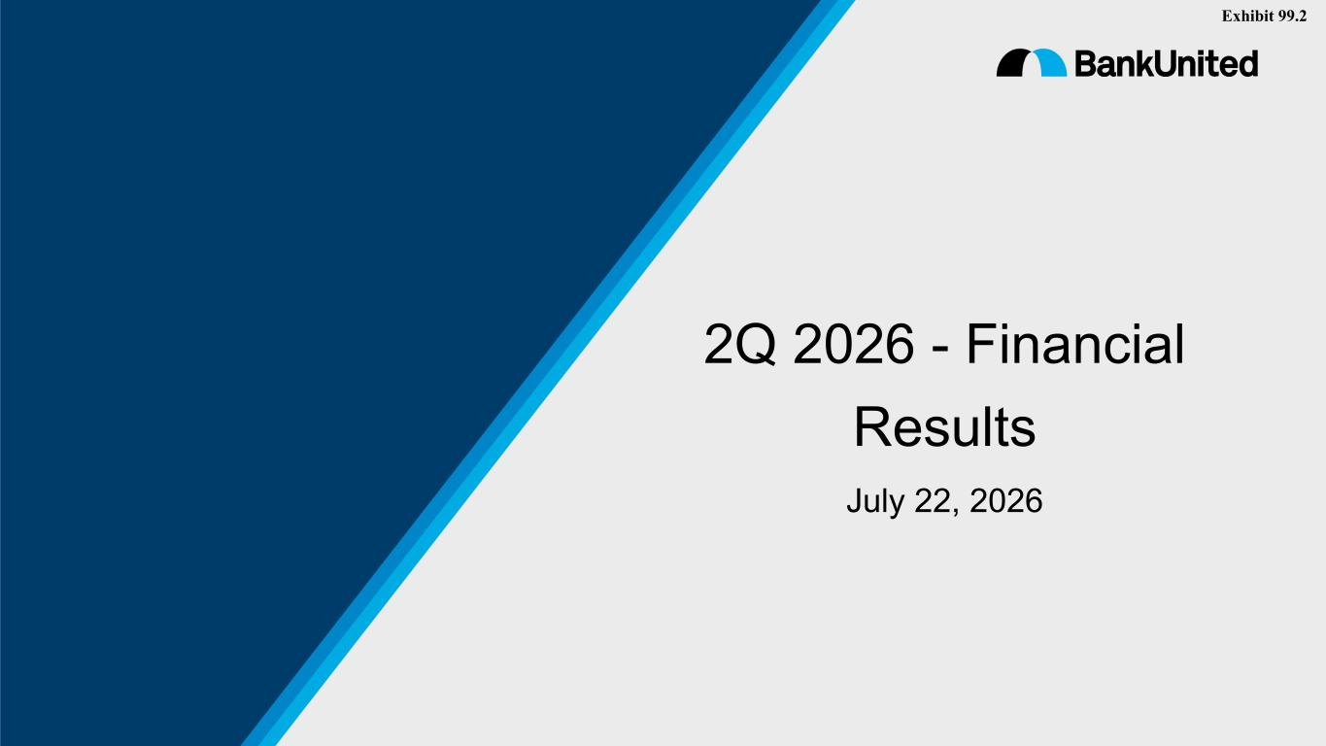
13

2Q 2026 - Financial Results July 22, 2026 Exhibit 99.2

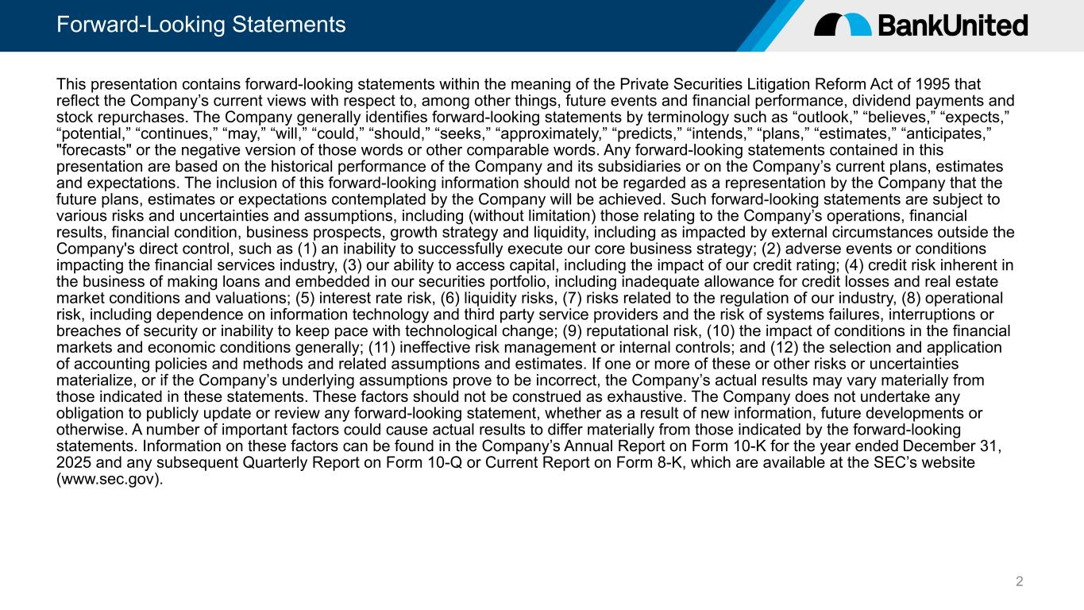
Forward-Looking Statements 2 This presentation contains forward-looking statements within the meaning of the Private Securities Litigation Reform Act of 1995 that reflect the Company’s current views with respect to, among other things, future events and financial performance, dividend payments and stock repurchases. The Company generally identifies forward-looking statements by terminology such as “outlook,” “believes,” “expects,” “potential,” “continues,” “may,” “will,” “could,” “should,” “seeks,” “approximately,” “predicts,” “intends,” “plans,” “estimates,” “anticipates,” "forecasts" or the negative version of those words or other comparable words. Any forward-looking statements contained in this presentation are based on the historical performance of the Company and its subsidiaries or on the Company’s current plans, estimates and expectations. The inclusion of this forward-looking information should not be regarded as a representation by the Company that the future plans, estimates or expectations contemplated by the Company will be achieved. Such forward-looking statements are subject to various risks and uncertainties and assumptions, including (without limitation) those relating to the Company’s operations, financial results, financial condition, business prospects, growth strategy and liquidity, including as impacted by external circumstances outside the Company's direct control, such as (1) an inability to successfully execute our core business strategy; (2) adverse events or conditions impacting the financial services industry, (3) our ability to access capital, including the impact of our credit rating; (4) credit risk inherent in the business of making loans and embedded in our securities portfolio, including inadequate allowance for credit losses and real estate market conditions and valuations; (5) interest rate risk, (6) liquidity risks, (7) risks related to the regulation of our industry, (8) operational risk, including dependence on information technology and third party service providers and the risk of systems failures, interruptions or breaches of security or inability to keep pace with technological change; (9) reputational risk, (10) the impact of conditions in the financial markets and economic conditions generally; (11) ineffective risk management or internal controls; and (12) the selection and application of accounting policies and methods and related assumptions and estimates. If one or more of these or other risks or uncertainties materialize, or if the Company’s underlying assumptions prove to be incorrect, the Company’s actual results may vary materially from those indicated in these statements. These factors should not be construed as exhaustive. The Company does not undertake any obligation to publicly update or review any forward-looking statement, whether as a result of new information, future developments or otherwise. A number of important factors could cause actual results to differ materially from those indicated by the forward-looking statements. Information on these factors can be found in the Company’s Annual Report on Form 10-K for the year ended December 31, 2025 and any subsequent Quarterly Report on Form 10-Q or Current Report on Form 8-K, which are available at the SEC’s website (www.sec.gov).

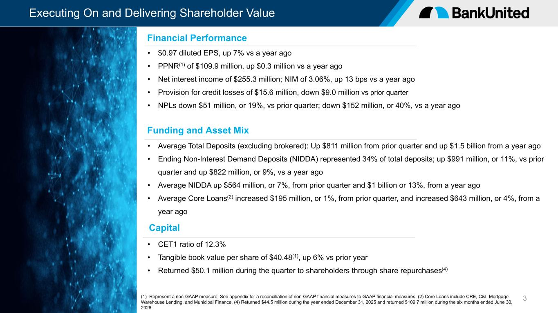
Executing On and Delivering Shareholder Value 3 • $0.97 diluted EPS, up 7% vs a year ago • PPNR(1) of $109.9 million, up $0.3 million vs a year ago • Net interest income of $255.3 million; NIM of 3.06%, up 13 bps vs a year ago • Provision for credit losses of $15.6 million, down $9.0 million vs prior quarter • NPLs down $51 million, or 19%, vs prior quarter; down $152 million, or 40%, vs a year ago • Average Total Deposits (excluding brokered): Up $811 million from prior quarter and up $1.5 billion from a year ago • Ending Non-Interest Demand Deposits (NIDDA) represented 34% of total deposits; up $991 million, or 11%, vs prior quarter and up $822 million, or 9%, vs a year ago • Average NIDDA up $564 million, or 7%, from prior quarter and $1 billion or 13%, from a year ago • Average Core Loans(2) increased $195 million, or 1%, from prior quarter, and increased $643 million, or 4%, from a year ago Financial Performance Funding and Asset Mix (1) Represent a non-GAAP measure. See appendix for a reconciliation of non-GAAP financial measures to GAAP financial measures. (2) Core Loans include CRE, C&I, Mortgage Warehouse Lending, and Municipal Finance. (4) Returned $44.5 million during the year ended December 31, 2025 and returned $109.7 million during the six months ended June 30, 2026. Capital • CET1 ratio of 12.3% • Tangible book value per share of $40.48(1), up 6% vs prior year • Returned $50.1 million during the quarter to shareholders through share repurchases(4)

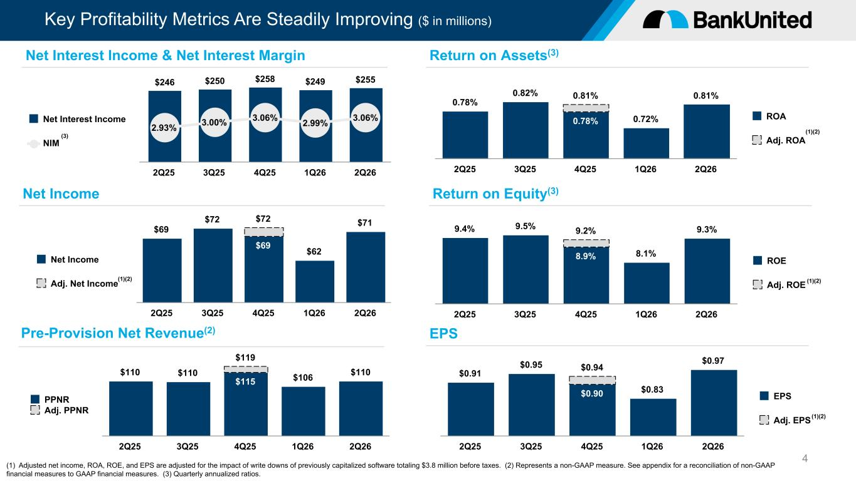
Key Profitability Metrics Are Steadily Improving ($ in millions) 4 $69 $72 $72 $62 $71 $69 Net Income Adj. Net Income 2Q25 3Q25 4Q25 1Q26 2Q26 9.4% 9.5% 9.2% 8.1% 9.3% 8.9% ROE Adj. ROE 2Q25 3Q25 4Q25 1Q26 2Q26 $246 $250 $258 $249 $255 2.93% 3.00% 3.06% 2.99% 3.06%Net Interest Income NIM 2Q25 3Q25 4Q25 1Q26 2Q26 0.78% 0.82% 0.81% 0.72% 0.81% 0.78% ROA Adj. ROA 2Q25 3Q25 4Q25 1Q26 2Q26 Net Interest Income & Net Interest Margin Net Income Return on Assets(3) Return on Equity(3) $110 $110 $119 $106 $110 $115 PPNR Adj. PPNR 2Q25 3Q25 4Q25 1Q26 2Q26 Pre-Provision Net Revenue(2) $0.91 $0.95 $0.94 $0.83 $0.97 $0.90 EPS Adj. EPS 2Q25 3Q25 4Q25 1Q26 2Q26 EPS (1) Adjusted net income, ROA, ROE, and EPS are adjusted for the impact of write downs of previously capitalized software totaling $3.8 million before taxes. (2) Represents a non-GAAP measure. See appendix for a reconciliation of non-GAAP financial measures to GAAP financial measures. (3) Quarterly annualized ratios. (1)(2) (1)(2) (1)(2) (1)(2) (3)

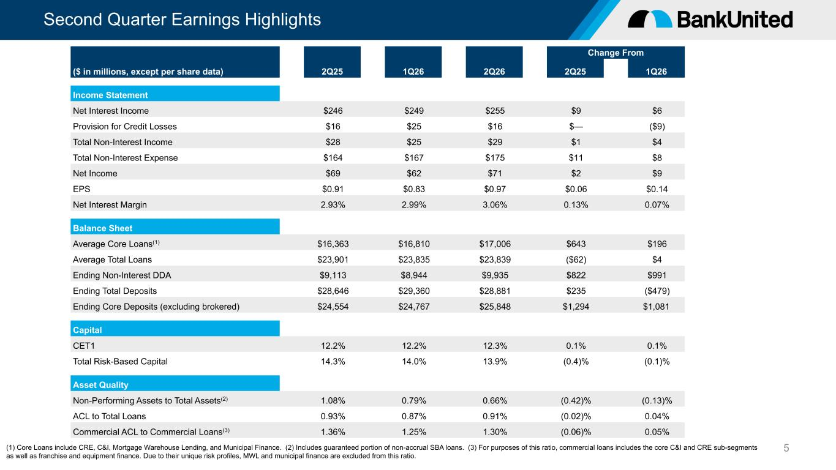
Second Quarter Earnings Highlights 5 Change From ($ in millions, except per share data) 2Q25 1Q26 2Q26 2Q25 1Q26 Income Statement Net Interest Income $246 $249 $255 $9 $6 Provision for Credit Losses $16 $25 $16 $— ($9) Total Non-Interest Income $28 $25 $29 $1 $4 Total Non-Interest Expense $164 $167 $175 $11 $8 Net Income $69 $62 $71 $2 $9 EPS $0.91 $0.83 $0.97 $0.06 $0.14 Net Interest Margin 2.93% 2.99% 3.06% 0.13% 0.07% Balance Sheet Average Core Loans(1) $16,363 $16,810 $17,006 $643 $196 Average Total Loans $23,901 $23,835 $23,839 ($62) $4 Ending Non-Interest DDA $9,113 $8,944 $9,935 $822 $991 Ending Total Deposits $28,646 $29,360 $28,881 $235 ($479) Ending Core Deposits (excluding brokered) $24,554 $24,767 $25,848 $1,294 $1,081 Capital CET1 12.2% 12.2% 12.3% 0.1% 0.1% Total Risk-Based Capital 14.3% 14.0% 13.9% (0.4)% (0.1)% Asset Quality Non-Performing Assets to Total Assets(2) 1.08% 0.79% 0.66% (0.42)% (0.13)% ACL to Total Loans 0.93% 0.87% 0.91% (0.02)% 0.04% Commercial ACL to Commercial Loans(3) 1.36% 1.25% 1.30% (0.06)% 0.05% (1) Core Loans include CRE, C&I, Mortgage Warehouse Lending, and Municipal Finance. (2) Includes guaranteed portion of non-accrual SBA loans. (3) For purposes of this ratio, commercial loans includes the core C&I and CRE sub-segments as well as franchise and equipment finance. Due to their unique risk profiles, MWL and municipal finance are excluded from this ratio.

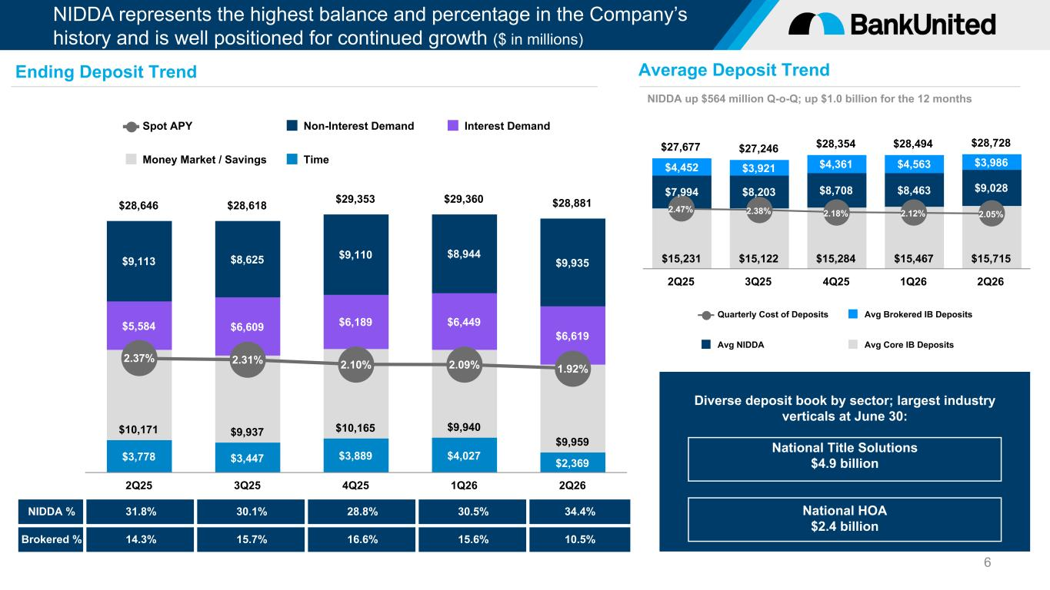
NIDDA represents the highest balance and percentage in the Company’s history and is well positioned for continued growth ($ in millions) $3,778 $3,447 $3,889 $4,027 $2,369 $10,171 $9,937 $10,165 $9,940 $9,959 $5,584 $6,609 $6,189 $6,449 $6,619 $9,113 $8,625 $9,110 $8,944 $9,935 $28,646 $28,618 $29,353 $29,360 $28,881 2.37% 2.31% 2.10% 2.09% 1.92% Spot APY Non-Interest Demand Interest Demand Money Market / Savings Time 2Q25 3Q25 4Q25 1Q26 2Q26 6 NIDDA % 31.8% 30.1% 28.8% 30.5% 34.4% Brokered % 14.3% 15.7% 16.6% 15.6% 10.5% Diverse deposit book by sector; largest industry verticals at June 30: National Title Solutions $4.9 billion National HOA $2.4 billion Ending Deposit Trend Average Deposit Trend NIDDA up $564 million Q-o-Q; up $1.0 billion for the 12 months $27,677 $27,246 $28,354 $28,494 $28,728 $15,231 $15,122 $15,284 $15,467 $15,715 $7,994 $8,203 $8,708 $8,463 $9,028 $4,452 $3,921 $4,361 $4,563 $3,986 2.47% 2.38% 2.18% 2.12% 2.05% Quarterly Cost of Deposits Avg Brokered IB Deposits Avg NIDDA Avg Core IB Deposits 2Q25 3Q25 4Q25 1Q26 2Q26

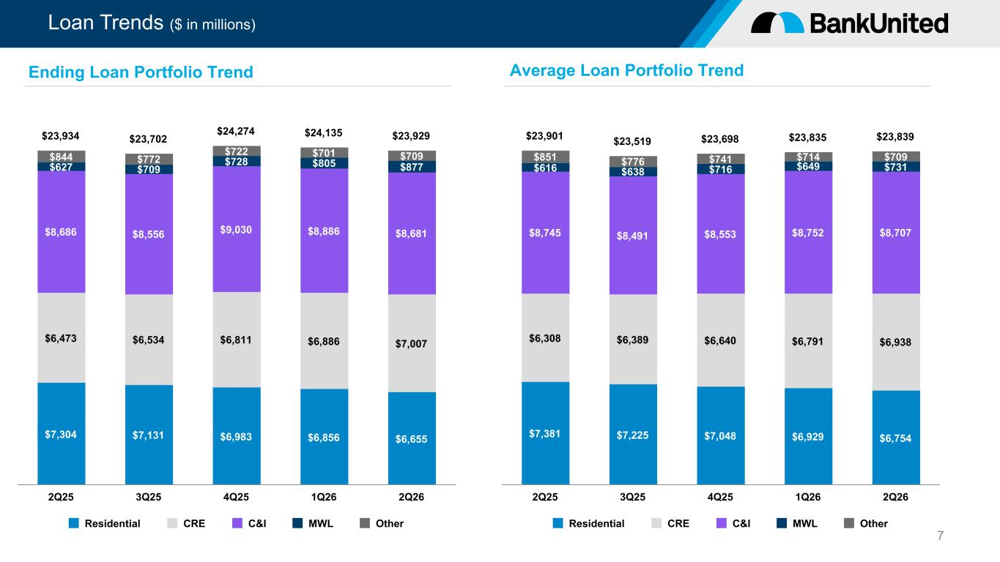
Loan Trends ($ in millions) $7,304 $7,131 $6,983 $6,856 $6,655 $6,473 $6,534 $6,811 $6,886 $7,007 $8,686 $8,556 $9,030 $8,886 $8,681 $627 $709 $728 $805 $877 $844 $772 $722 $701 $709 $23,934 $23,702 $24,274 $24,135 $23,929 Residential CRE C&I MWL Other 2Q25 3Q25 4Q25 1Q26 2Q26 7 Ending Loan Portfolio Trend Average Loan Portfolio Trend $7,381 $7,225 $7,048 $6,929 $6,754 $6,308 $6,389 $6,640 $6,791 $6,938 $8,745 $8,491 $8,553 $8,752 $8,707 $616 $638 $716 $649 $731 $851 $776 $741 $714 $709 $23,901 $23,519 $23,698 $23,835 $23,839 Residential CRE C&I MWL Other 2Q25 3Q25 4Q25 1Q26 2Q26

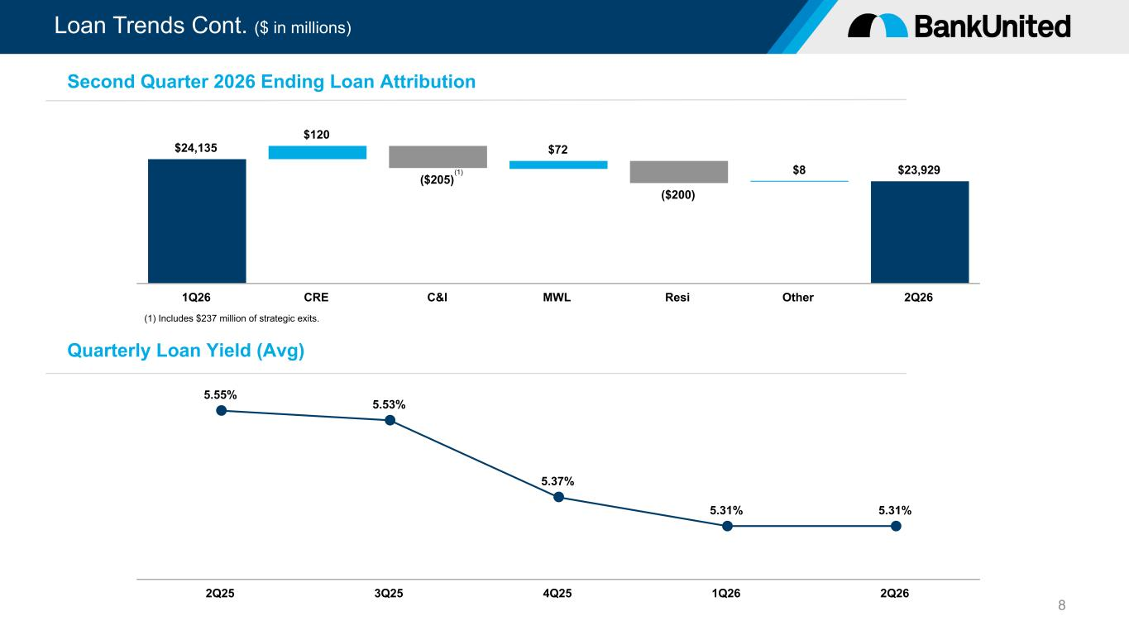
Loan Trends Cont. ($ in millions) 8 $24,135 $120 ($205) $72 ($200) $8 $23,929 1Q26 CRE C&I MWL Resi Other 2Q26 Second Quarter 2026 Ending Loan Attribution 5.55% 5.53% 5.37% 5.31% 5.31% 2Q25 3Q25 4Q25 1Q26 2Q26 Quarterly Loan Yield (Avg) (1) Includes $237 million of strategic exits. (1)

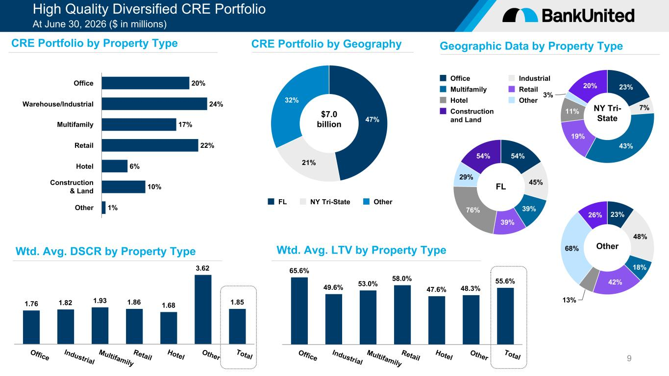
High Quality Diversified CRE Portfolio At June 30, 2026 ($ in millions) 9 $7.0 billion 47% 21% 32% FL NY Tri-State Other 20% 24% 17% 22% 6% 10% 1% Office Warehouse/Industrial Multifamily Retail Hotel Construction & Land Other 1.76 1.82 1.93 1.86 1.68 3.62 1.85 Office Industrial Multifamily Retail Hotel Other Total 65.6% 49.6% 53.0% 58.0% 47.6% 48.3% 55.6% Office Industrial Multifamily Retail Hotel Other Total 54% 45% 39% 39% 76% 29% 54% Office Industrial Multifamily Retail Hotel Other Construction and Land 23% 7% 43% 19% 11% 3% 20% 23% 48% 18% 42% 13% 68% 26% Other FL NY Tri- State CRE Portfolio by Property Type Wtd. Avg. DSCR by Property Type CRE Portfolio by Geography Geographic Data by Property Type Wtd. Avg. LTV by Property Type

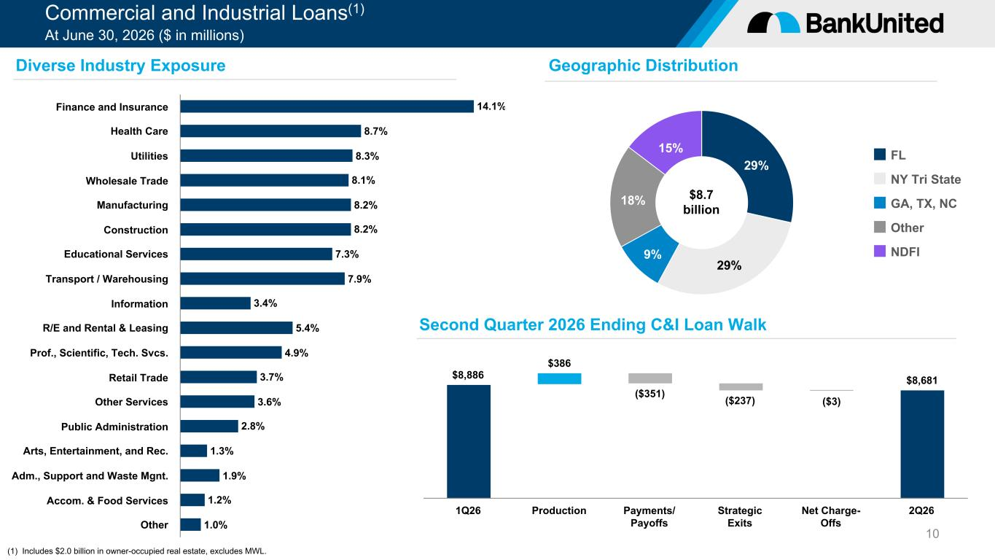
Commercial and Industrial Loans(1) At June 30, 2026 ($ in millions) 10 14.1% 8.7% 8.3% 8.1% 8.2% 8.2% 7.3% 7.9% 3.4% 5.4% 4.9% 3.7% 3.6% 2.8% 1.3% 1.9% 1.2% 1.0% Finance and Insurance Health Care Utilities Wholesale Trade Manufacturing Construction Educational Services Transport / Warehousing Information R/E and Rental & Leasing Prof., Scientific, Tech. Svcs. Retail Trade Other Services Public Administration Arts, Entertainment, and Rec. Adm., Support and Waste Mgnt. Accom. & Food Services Other $8,886 $386 ($351) ($237) ($3) $8,681 1Q26 Production Payments/ Payoffs Strategic Exits Net Charge- Offs 2Q26 29% 29% 9% 18% 15% FL NY Tri State GA, TX, NC Other NDFI Diverse Industry Exposure Geographic Distribution Second Quarter 2026 Ending C&I Loan Walk $8.7 billion (1) Includes $2.0 billion in owner-occupied real estate, excludes MWL.

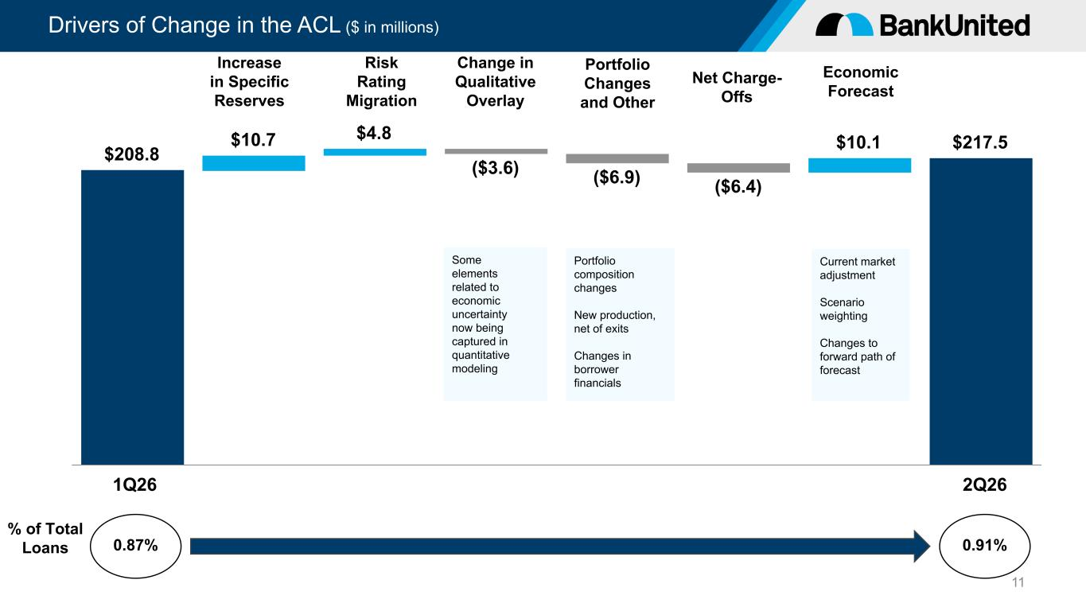
Drivers of Change in the ACL ($ in millions) 11 $208.8 $10.7 $4.8 ($3.6) ($6.9) ($6.4) $10.1 $217.5 1Q26 2Q26 % of Total Loans 0.87% 0.91% Increase in Specific Reserves Risk Rating Migration Change in Qualitative Overlay Portfolio Changes and Other Net Charge- Offs Economic Forecast Current market adjustment Scenario weighting Changes to forward path of forecast Portfolio composition changes New production, net of exits Changes in borrower financials Some elements related to economic uncertainty now being captured in quantitative modeling

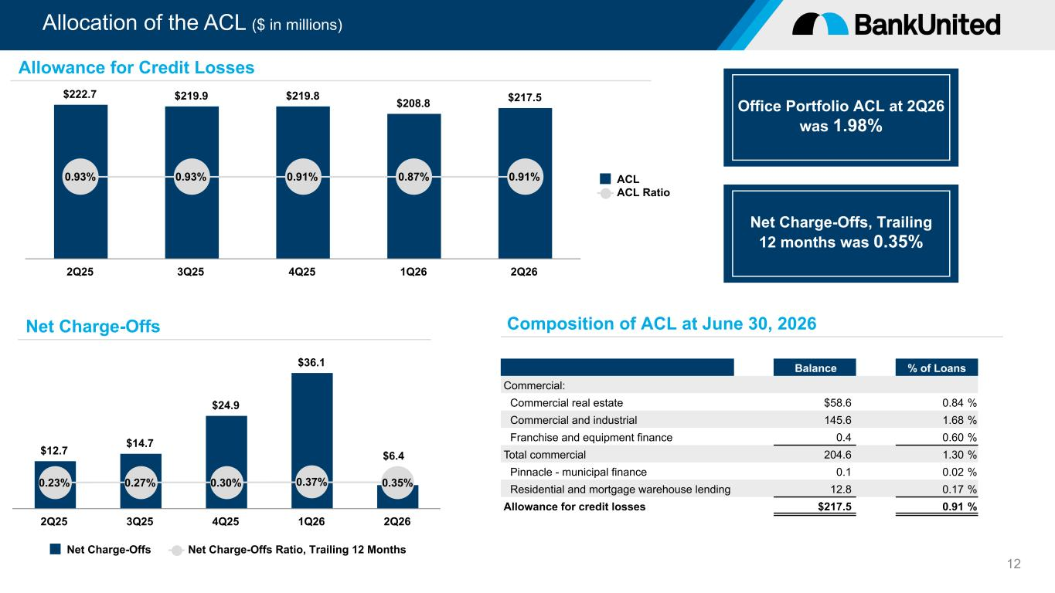
Allocation of the ACL ($ in millions) 12 Office Portfolio ACL at 2Q26 was 1.98% $222.7 $219.9 $219.8 $208.8 $217.5 0.93% 0.93% 0.91% 0.87% 0.91% ACL ACL Ratio 2Q25 3Q25 4Q25 1Q26 2Q26 $12.7 $14.7 $24.9 $36.1 0.23% 0.27% 0.30% 0.37% 0.35% Net Charge-Offs Net Charge-Offs Ratio, Trailing 12 Months 2Q25 3Q25 4Q25 1Q26 2Q26 Allowance for Credit Losses Net Charge-Offs Composition of ACL at June 30, 2026 Balance % of Loans Commercial: Commercial real estate $58.6 0.84 % Commercial and industrial 145.6 1.68 % Franchise and equipment finance 0.4 0.60 % Total commercial 204.6 1.30 % Pinnacle - municipal finance 0.1 0.02 % Residential and mortgage warehouse lending 12.8 0.17 % Allowance for credit losses $217.5 0.91 % Net Charge-Offs, Trailing 12 months was 0.35% $6.4

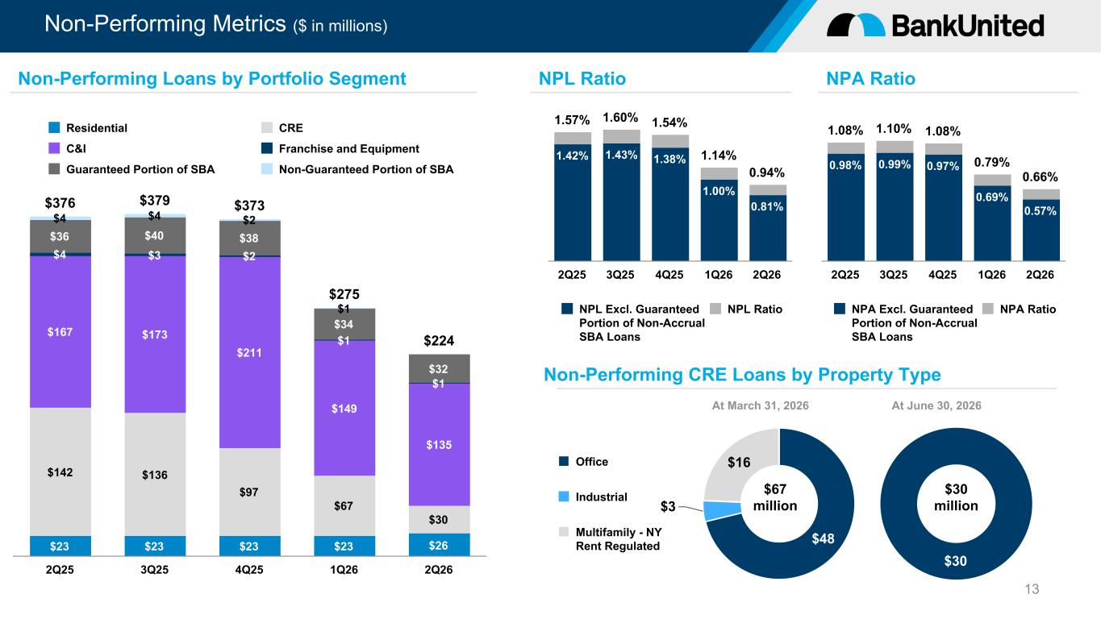
Non-Performing Metrics ($ in millions) 13 1.57% 1.60% 1.54% 1.14% 0.94% 1.42% 1.43% 1.38% 1.00% 0.81% NPL Excl. Guaranteed Portion of Non-Accrual SBA Loans NPL Ratio 2Q25 3Q25 4Q25 1Q26 2Q26 NPL RatioNon-Performing Loans by Portfolio Segment $376 $379 $373 $275 $224 $23 $23 $23 $23 $26 $142 $136 $97 $67 $30 $167 $173 $211 $149 $135 $4 $3 $2 $1 $1 $36 $40 $38 $34 $32 $4 $4 $2 $1 Residential CRE C&I Franchise and Equipment Guaranteed Portion of SBA Non-Guaranteed Portion of SBA 2Q25 3Q25 4Q25 1Q26 2Q26 1.08% 1.10% 1.08% 0.79% 0.66% 0.98% 0.99% 0.97% 0.69% 0.57% NPA Excl. Guaranteed Portion of Non-Accrual SBA Loans NPA Ratio 2Q25 3Q25 4Q25 1Q26 2Q26 NPA Ratio $30 Non-Performing CRE Loans by Property Type At June 30, 2026 $30 million $48 $3 $16Office Industrial Multifamily - NY Rent Regulated At March 31, 2026 $67 million

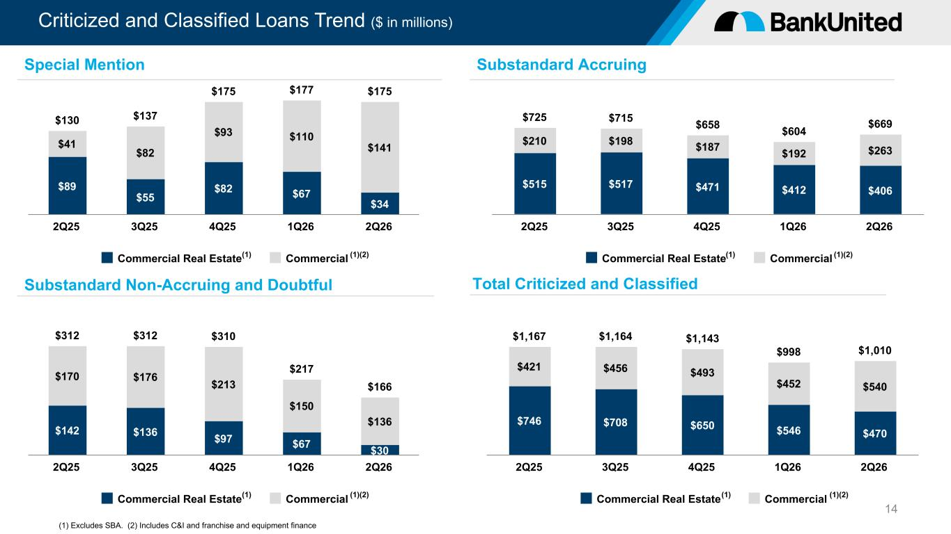
Criticized and Classified Loans Trend ($ in millions) 14 $130 $137 $175 $177 $175 $89 $55 $82 $67 $34 $41 $82 $93 $110 $141 Commercial Real Estate Commercial 2Q25 3Q25 4Q25 1Q26 2Q26 $312 $312 $310 $217 $166 $142 $136 $97 $67 $30 $170 $176 $213 $150 $136 Commercial Real Estate Commercial 2Q25 3Q25 4Q25 1Q26 2Q26 (1) Excludes SBA. (2) Includes C&I and franchise and equipment finance Special Mention Substandard Non-Accruing and Doubtful $725 $715 $658 $604 $669 $515 $517 $471 $412 $406 $210 $198 $187 $192 $263 Commercial Real Estate Commercial 2Q25 3Q25 4Q25 1Q26 2Q26 $1,167 $1,164 $1,143 $998 $1,010 $746 $708 $650 $546 $470 $421 $456 $493 $452 $540 Commercial Real Estate Commercial 2Q25 3Q25 4Q25 1Q26 2Q26 Total Criticized and Classified Substandard Accruing (1) (1)(2) (1) (1)(2) (1) (1)(2) (1) (1)(2)

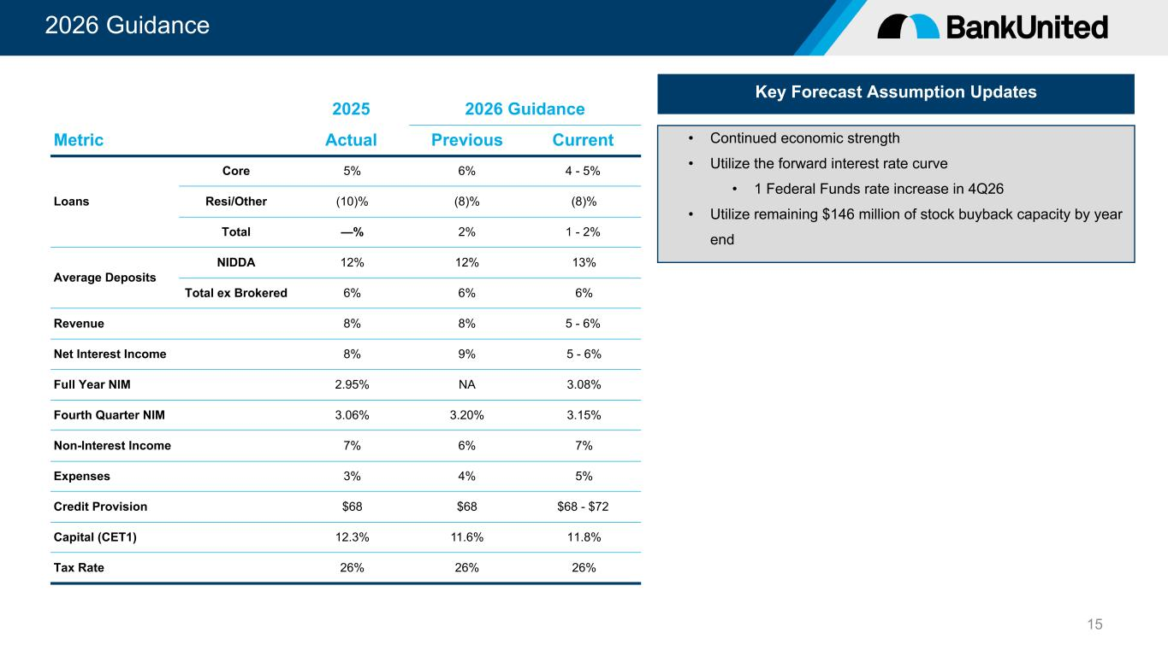
2026 Guidance 15 Key Forecast Assumption Updates • Continued economic strength • Utilize the forward interest rate curve • 1 Federal Funds rate increase in 4Q26 • Utilize remaining $146 million of stock buyback capacity by year end 2025 2026 Guidance Metric Actual Previous Current Loans Core 5% 6% 4 - 5% Resi/Other (10)% (8)% (8)% Total —% 2% 1 - 2% Average Deposits NIDDA 12% 12% 13% Total ex Brokered 6% 6% 6% Revenue 8% 8% 5 - 6% Net Interest Income 8% 9% 5 - 6% Full Year NIM 2.95% NA 3.08% Fourth Quarter NIM 3.06% 3.20% 3.15% Non-Interest Income 7% 6% 7% Expenses 3% 4% 5% Credit Provision $68 $68 $68 - $72 Capital (CET1) 12.3% 11.6% 11.8% Tax Rate 26% 26% 26%

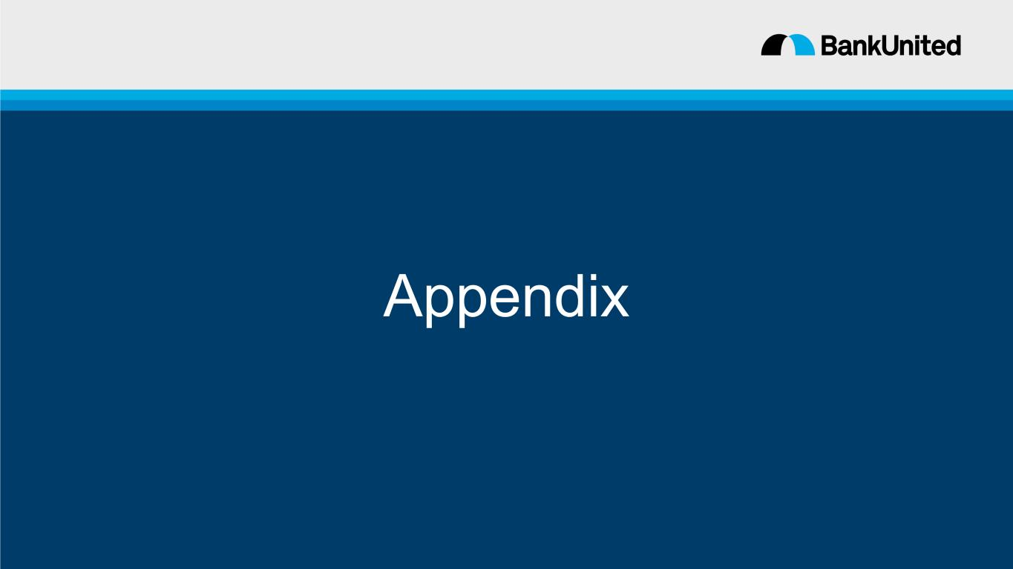
Appendix

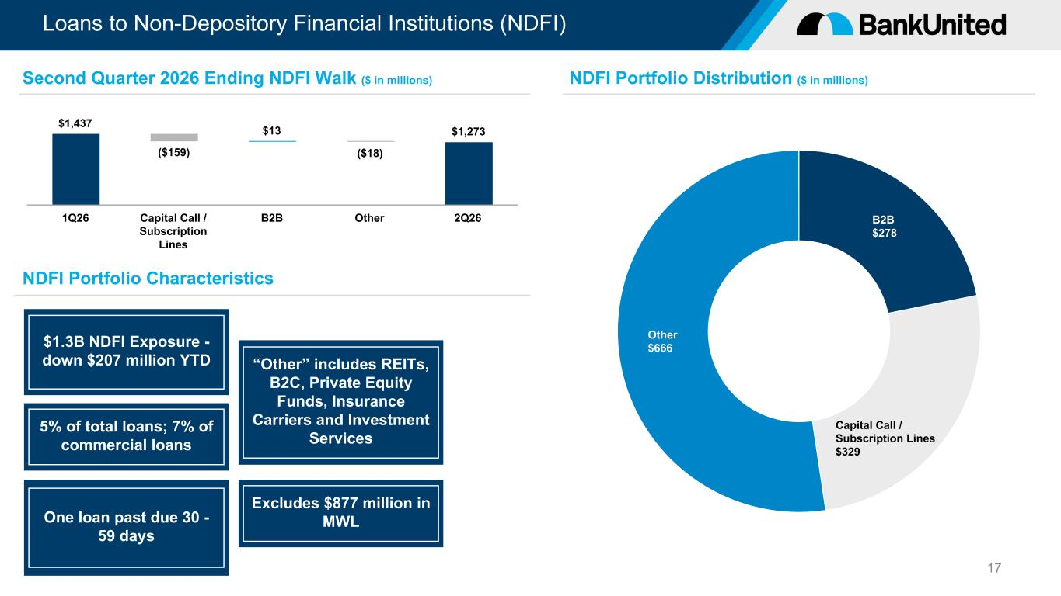
Loans to Non-Depository Financial Institutions (NDFI) 17 “Other” includes REITs, B2C, Private Equity Funds, Insurance Carriers and Investment Services NDFI Portfolio Characteristics $1.3B NDFI Exposure - down $207 million YTD 5% of total loans; 7% of commercial loans One loan past due 30 - 59 days Excludes $877 million in MWL $1,437 ($159) $13 ($18) $1,273 1Q26 Capital Call / Subscription Lines B2B Other 2Q26 B2B $278 Capital Call / Subscription Lines $329 Other $666 Second Quarter 2026 Ending NDFI Walk ($ in millions) NDFI Portfolio Distribution ($ in millions)

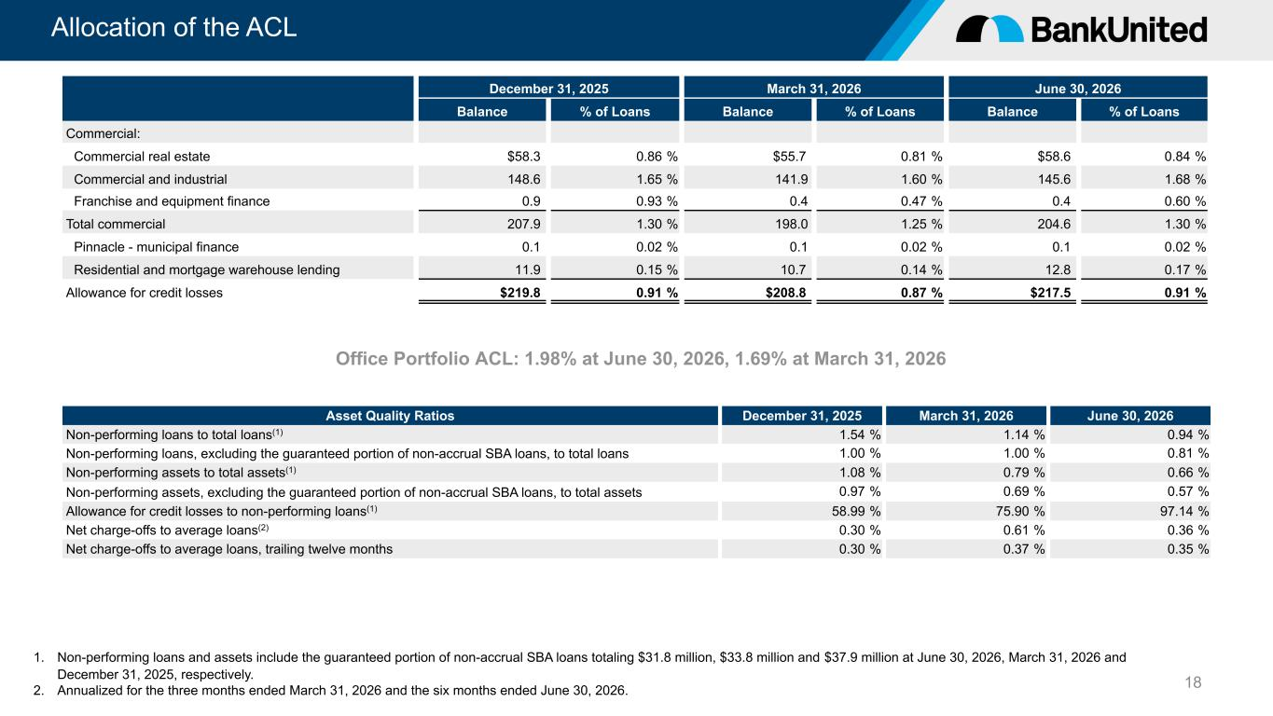
Allocation of the ACL 18 December 31, 2025 March 31, 2026 June 30, 2026 Balance % of Loans Balance % of Loans Balance % of Loans Commercial: Commercial real estate $58.3 0.86 % $55.7 0.81 % $58.6 0.84 % Commercial and industrial 148.6 1.65 % 141.9 1.60 % 145.6 1.68 % Franchise and equipment finance 0.9 0.93 % 0.4 0.47 % 0.4 0.60 % Total commercial 207.9 1.30 % 198.0 1.25 % 204.6 1.30 % Pinnacle - municipal finance 0.1 0.02 % 0.1 0.02 % 0.1 0.02 % Residential and mortgage warehouse lending 11.9 0.15 % 10.7 0.14 % 12.8 0.17 % Allowance for credit losses $219.8 0.91 % $208.8 0.87 % $217.5 0.91 % [Office Portfolio ACL: 1.98% at June 30, 2026, 1.69% at March 31, 2026 Asset Quality Ratios December 31, 2025 March 31, 2026 June 30, 2026 Non-performing loans to total loans(1) 1.54 % 1.14 % 0.94 % Non-performing loans, excluding the guaranteed portion of non-accrual SBA loans, to total loans 1.00 % 1.00 % 0.81 % Non-performing assets to total assets(1) 1.08 % 0.79 % 0.66 % Non-performing assets, excluding the guaranteed portion of non-accrual SBA loans, to total assets 0.97 % 0.69 % 0.57 % Allowance for credit losses to non-performing loans(1) 58.99 % 75.90 % 97.14 % Net charge-offs to average loans(2) 0.30 % 0.61 % 0.36 % Net charge-offs to average loans, trailing twelve months 0.30 % 0.37 % 0.35 % 1. Non-performing loans and assets include the guaranteed portion of non-accrual SBA loans totaling $31.8 million, $33.8 million and $37.9 million at June 30, 2026, March 31, 2026 and December 31, 2025, respectively. 2. Annualized for the three months ended March 31, 2026 and the six months ended June 30, 2026.

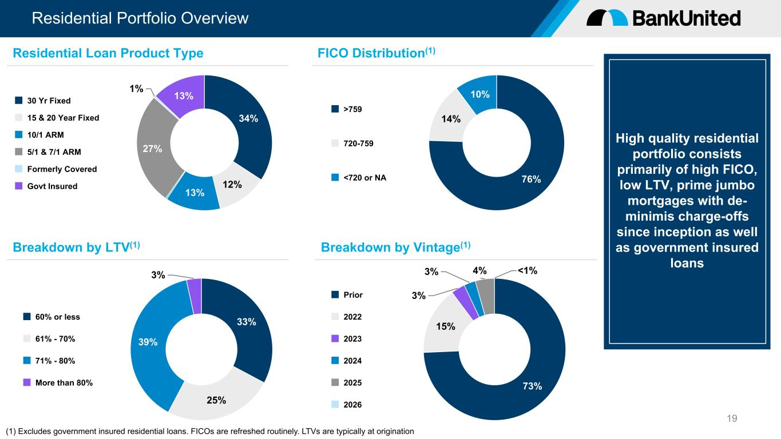
Residential Portfolio Overview 19 34% 12% 13% 27% 1% 13%30 Yr Fixed 15 & 20 Year Fixed 10/1 ARM 5/1 & 7/1 ARM Formerly Covered Govt Insured 33% 25% 39% 3% 60% or less 61% - 70% 71% - 80% More than 80% 76% 14% 10% >759 720-759 <720 or NA 73% 15% 3% 3% 4% <1% Prior 2022 2023 2024 2025 2026 High quality residential portfolio consists primarily of high FICO, low LTV, prime jumbo mortgages with de- minimis charge-offs since inception as well as government insured loans (1) Excludes government insured residential loans. FICOs are refreshed routinely. LTVs are typically at origination Residential Loan Product Type Breakdown by LTV(1) FICO Distribution(1) Breakdown by Vintage(1)

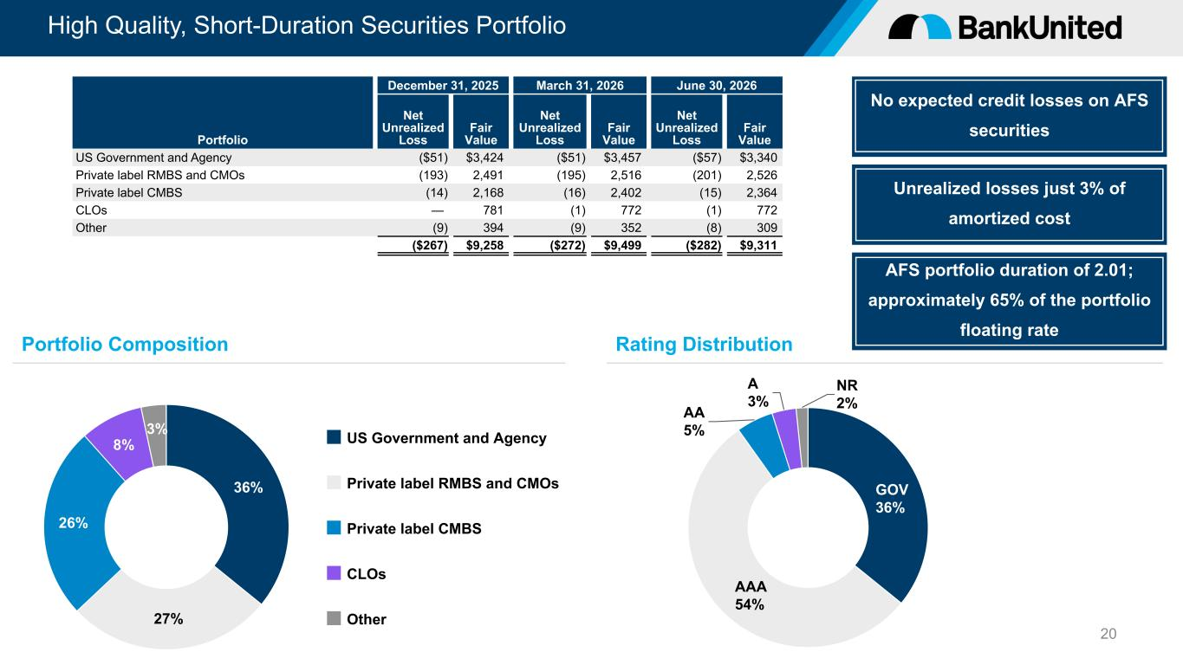
High Quality, Short-Duration Securities Portfolio 20 36% 27% 26% 8% 3% US Government and Agency Private label RMBS and CMOs Private label CMBS CLOs Other GOV 36% AAA 54% AA 5% A 3% NR 2% December 31, 2025 March 31, 2026 June 30, 2026 Portfolio Net Unrealized Loss Fair Value Net Unrealized Loss Fair Value Net Unrealized Loss Fair Value US Government and Agency ($51) $3,424 ($51) $3,457 ($57) $3,340 Private label RMBS and CMOs (193) 2,491 (195) 2,516 (201) 2,526 Private label CMBS (14) 2,168 (16) 2,402 (15) 2,364 CLOs — 781 (1) 772 (1) 772 Other (9) 394 (9) 352 (8) 309 ($267) $9,258 ($272) $9,499 ($282) $9,311 Portfolio Composition Rating Distribution No expected credit losses on AFS securities Unrealized losses just 3% of amortized cost AFS portfolio duration of 2.01; approximately 65% of the portfolio floating rate

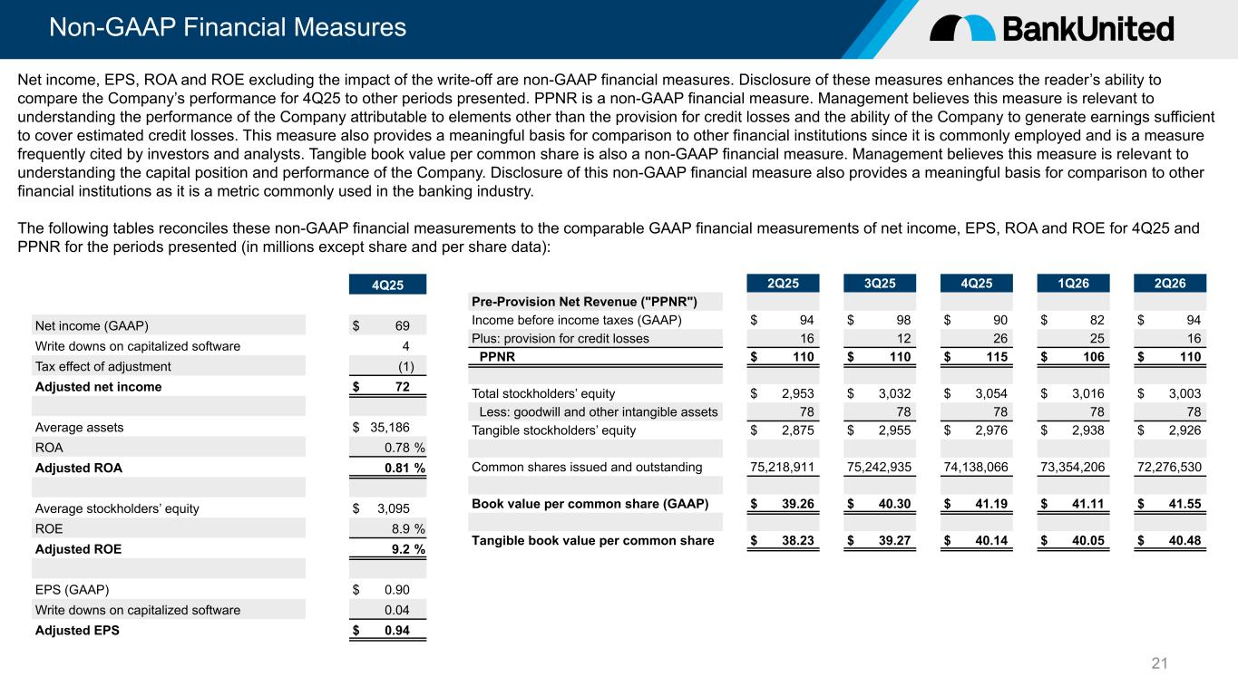
Non-GAAP Financial Measures 21 4Q25 Net income (GAAP) $ 69 Write downs on capitalized software 4 Tax effect of adjustment (1) Adjusted net income $ 72 Average assets $ 35,186 ROA 0.78 % Adjusted ROA 0.81 % Average stockholders’ equity $ 3,095 ROE 8.9 % Adjusted ROE 9.2 % EPS (GAAP) $ 0.90 Write downs on capitalized software 0.04 Adjusted EPS $ 0.94 Net income, EPS, ROA and ROE excluding the impact of the write-off are non-GAAP financial measures. Disclosure of these measures enhances the reader’s ability to compare the Company’s performance for 4Q25 to other periods presented. PPNR is a non-GAAP financial measure. Management believes this measure is relevant to understanding the performance of the Company attributable to elements other than the provision for credit losses and the ability of the Company to generate earnings sufficient to cover estimated credit losses. This measure also provides a meaningful basis for comparison to other financial institutions since it is commonly employed and is a measure frequently cited by investors and analysts. Tangible book value per common share is also a non-GAAP financial measure. Management believes this measure is relevant to understanding the capital position and performance of the Company. Disclosure of this non-GAAP financial measure also provides a meaningful basis for comparison to other financial institutions as it is a metric commonly used in the banking industry. The following tables reconciles these non-GAAP financial measurements to the comparable GAAP financial measurements of net income, EPS, ROA and ROE for 4Q25 and PPNR for the periods presented (in millions except share and per share data): 2Q25 3Q25 4Q25 1Q26 2Q26 Pre-Provision Net Revenue ("PPNR") Income before income taxes (GAAP) $ 94 $ 98 $ 90 $ 82 $ 94 Plus: provision for credit losses 16 12 26 25 16 PPNR $ 110 $ 110 $ 115 $ 106 $ 110 Total stockholders’ equity $ 2,953 $ 3,032 $ 3,054 $ 3,016 $ 3,003 Less: goodwill and other intangible assets 78 78 78 78 78 Tangible stockholders’ equity $ 2,875 $ 2,955 $ 2,976 $ 2,938 $ 2,926 Common shares issued and outstanding 75,218,911 75,242,935 74,138,066 73,354,206 72,276,530 Book value per common share (GAAP) $ 39.26 $ 40.30 $ 41.19 $ 41.11 $ 41.55 Tangible book value per common share $ 38.23 $ 39.27 $ 40.14 $ 40.05 $ 40.48

